**Customer Distribution and Deactivation Analyses**



**Objective:**

The attached data is the CRM data of a wireless company for 2 years. The wireless company would like to investigate the customer distribution and business behaviors, and then gain insightful understanding about the customers, and to forecast the deactivation trends for the next 6 months.

Data:

Acctno: account number.

Actdt: account activation date

Deactdt: account deactivation date

DeactReason: reason for deactivation.

GoodCredit: customer’s credit is good or not.

RatePlan: rate plan for the customer.

DealerType: dealer type.

Age: customer age.

Province: province.

Sales: the amount of sales to a customer.

To Load the dataset I followed the following approach.

As the dataset file is in txt format , used infile and input to get the dataset in table format.

libname kp "C:\Users\praka\OneDrive\Desktop\METRO\SAS\ADVANCE_SAS\PROJECT";

/*Loading the dataset file*/

/*Infile Specifies an external file to read with an INPUT statement.*/

/*Input Returns the value that is produced when SAS converts an expression by using the specified informat.*/

/*Format specifies the format that is listed for writing the values of the variables.*/

/*Informat specifies a temporary default informat for reading values of the variables that are listed in the INFORMAT statement. */

data kp.test1;

infile "C:\Users\praka\OneDrive\Desktop\METRO\SAS\ADVANCE_SAS\PROJECT\New_Wireless_Fixed.txt";

input Acctno $ 1-13

@15 Actdt mmddyy10.

@26 Deactdt mmddyy10.

DeactReason $ 41-44

GoodCredit 53

RatePlan $ 62

DealerType $ 65-66

Age 74-75

Province $ 80-81

Sales $ 82-92

;

format Actdt date9. Deactdt date9.

;

run;

proc print data = kp.test1(obs=50); run;

/*

Analysis requests:

1.1 Explore and describe the dataset briefly. For example, is the acctno unique? What

is the number of accounts activated and deactivated? When is the earliest and

latest activation/deactivation dates available? And so on…. */

/*Exploring the dataset */

title 'Description of Data';

**PROC** **CONTENTS** DATA=kp.test1;

**RUN**;

title;

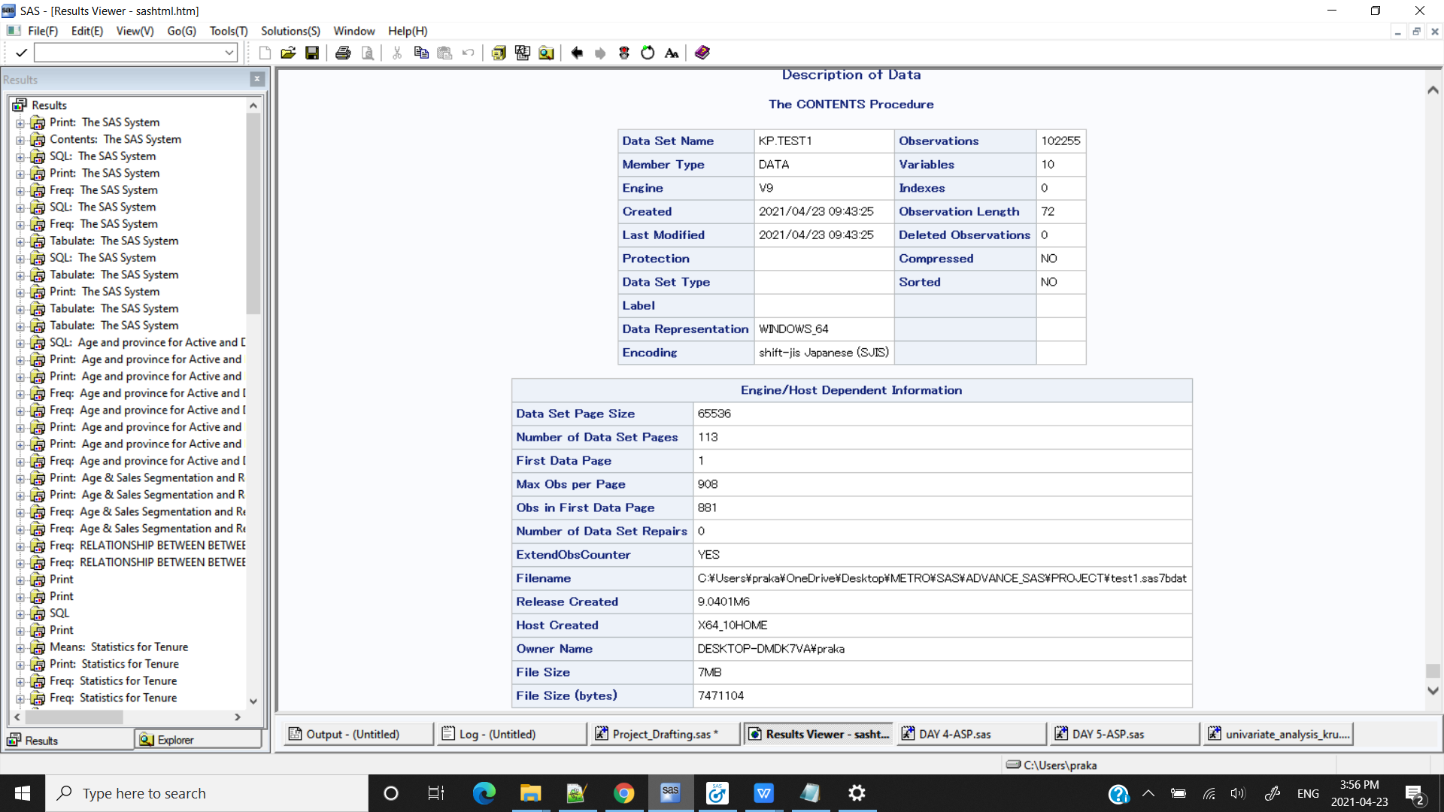

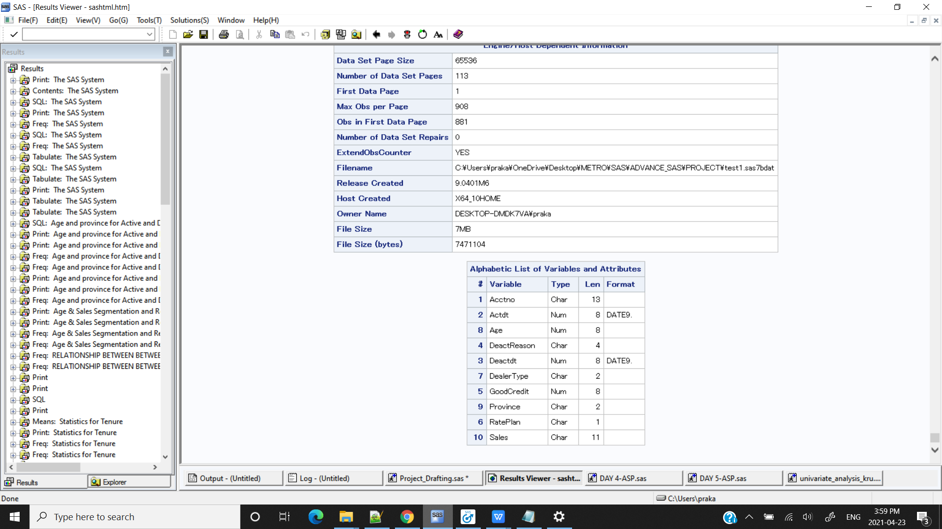

/*SAS SYNTAX*/

**proc** **sort** data = kp.test1 nodupkey;

by Acctno;

**run**;

/*PROC SQL SYNTAX*/

/*To extract all the unique Account numbers*/

**proc sql;**

**select count(*) as obs, count( distinct Acctno) as Acc**

**from kp.test1;**

**run;**

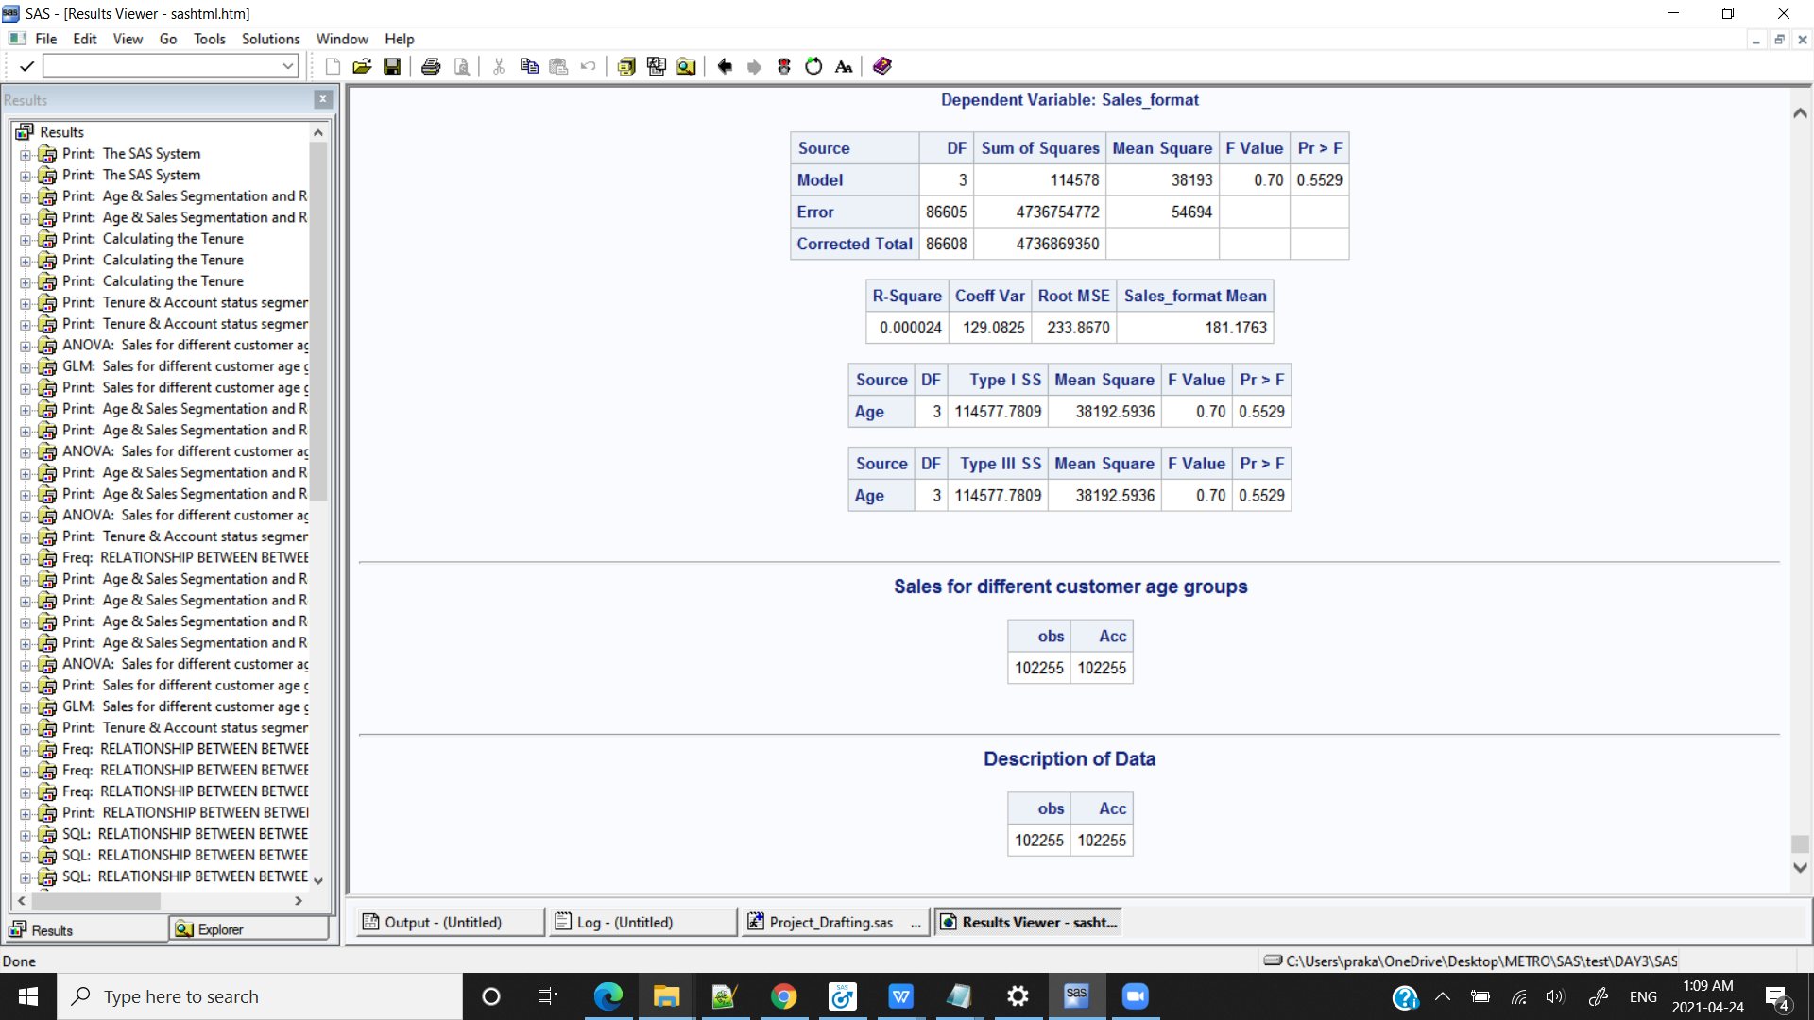

/*MACRO SYNTAX*/

/*To extract all the unique Account numbers using macro*/

**%macro** unique_accno(DSN=, var1=);

proc sort data = &DSN. nodupkey;

by &var1;

run;

**%mend**;

%***unique_accno***(DSN=kp.test1,var1=Acctno);

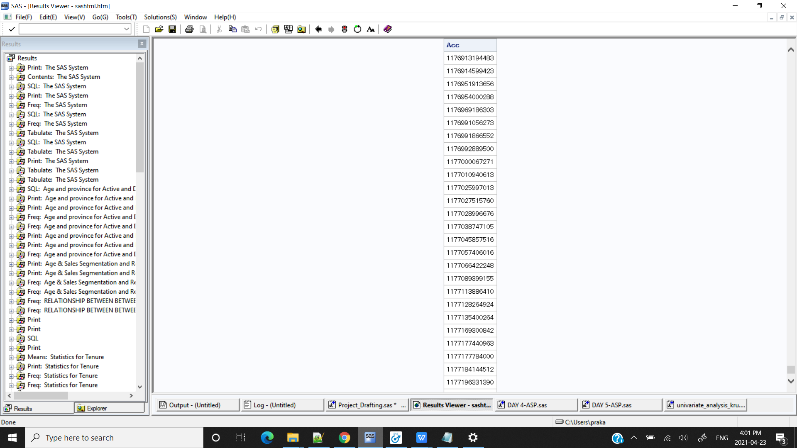

/*CONCLUSION : All the Account numbers are uunique*/

/*1.1 What is the number of accounts activated and deactivated? */

/*SAS SYNTAX*/

**data** kp.test2;

set kp.test1;

Sales = SUBSTR(Sales,**2**,**7**);

Sales_format = input(Sales, best12.);

if Deactdt='' then Account_Status='Active ';

else Account_Status = 'Deactivated';

**run**;

**proc** **print** data= kp.test2(obs=**10**);**run**;

**proc** **contents** data=kp.test2;

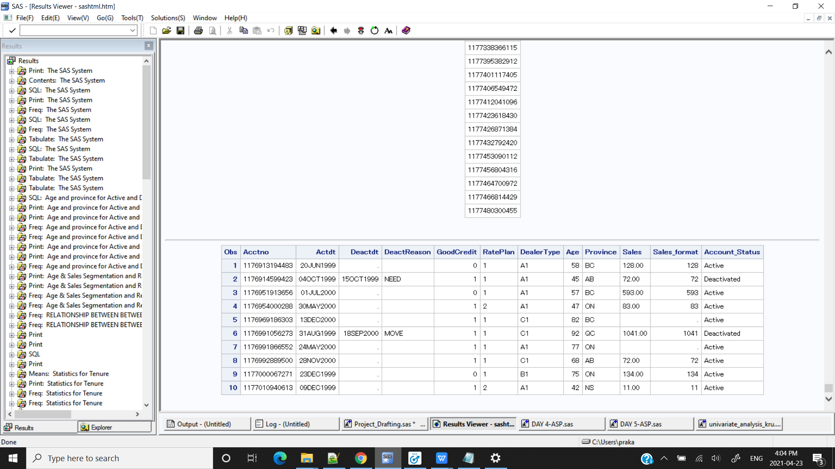

/*To classify the accounts as Activated or Deactivated based on deactivation date*/

/*Number of Accounts Activated and Deactivated*/

**proc** **freq** data=kp.test2;

tables Account_Status;

**run**;

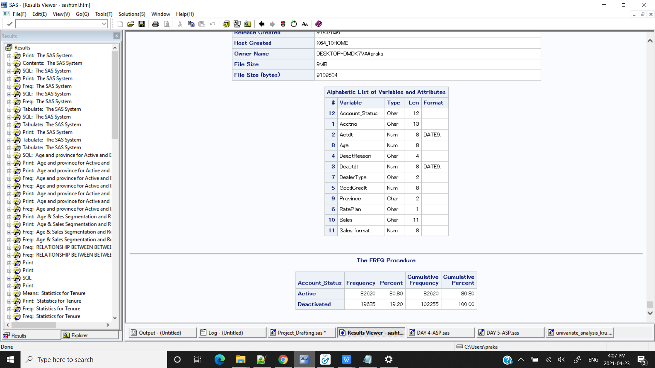

/*PROC SQL SYNTAX*/

**PROC** **SQL**;

SELECT Account_Status , count(Account_Status) as Acc_Count FROM kp.test2

group by Account_Status;

**QUIT**;

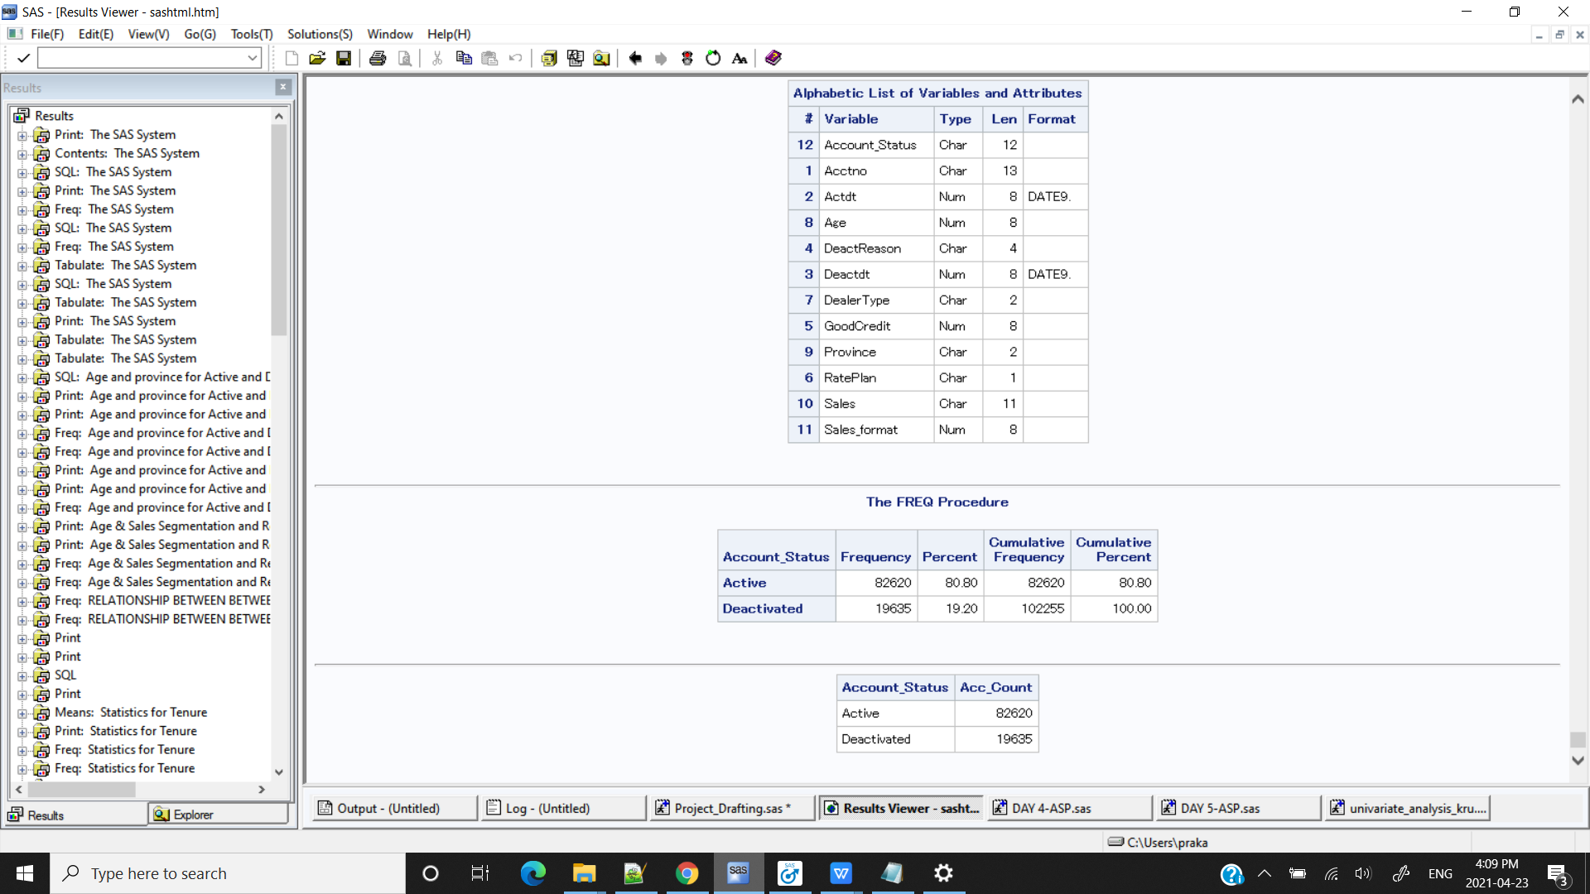

/*MACRO*/

**%macro** levels_variable(DSN=,var1=);

proc freq data= &DSN. ;

tables &var1;

run;

**%mend**;

%***levels_variable***(DSN=kp.test2,var1=Account_Status);



/*GRAPH*/

%include "C:\Users\praka\OneDrive\Desktop\METRO\SAS\ADVANCE_SAS\PROJECT\univariate_analysis.sas";

%***UNI_ANALYSIS_CAT_FORMAT***(kp.test2,Account_Status)

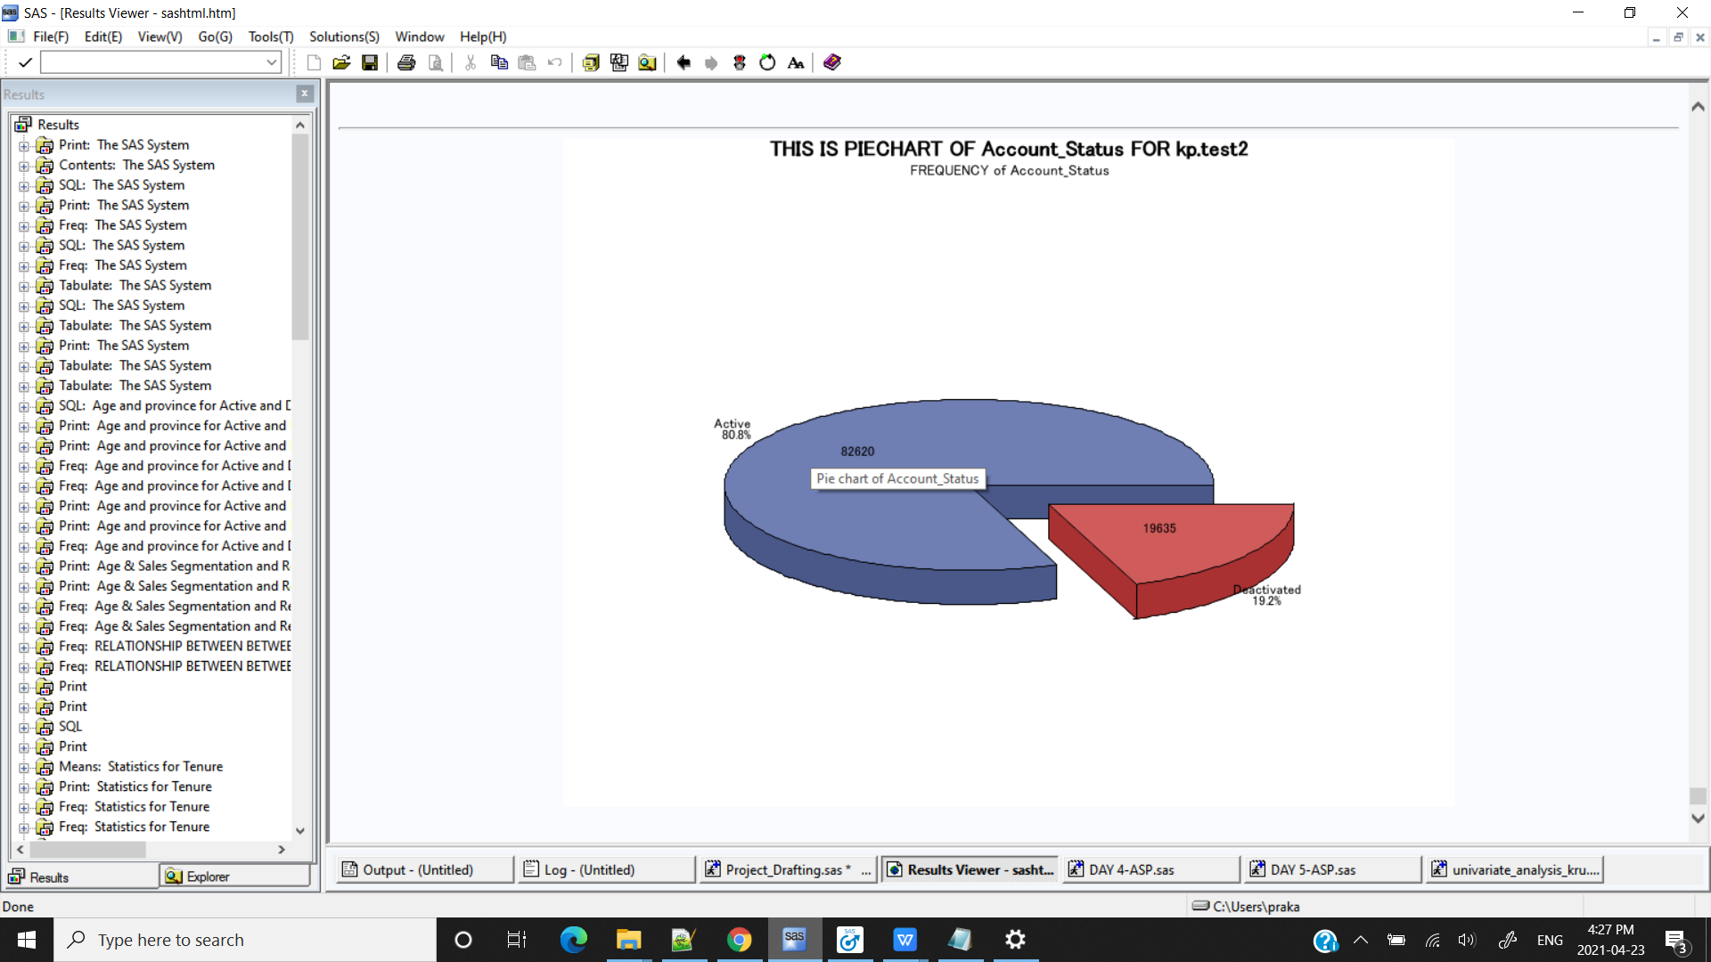

**/*CONCLUSION : The number of Active accounts is 82620 and the number of Deactivated Accounts is 19635.*/**

/*1.1 When is the earliest and latest activation/deactivation dates available?*/

/*SAS SYNTAX*/

title'Earliest and Latest date for Active & Deactive Account';

**proc** **tabulate** data=kp.test2 format=date9.;

var Actdt Deactdt;

table Actdt=Actdt*(min='min date' max='max date') Deactdt= Deactdt*(min='min date' max='max date') ;

**run**;

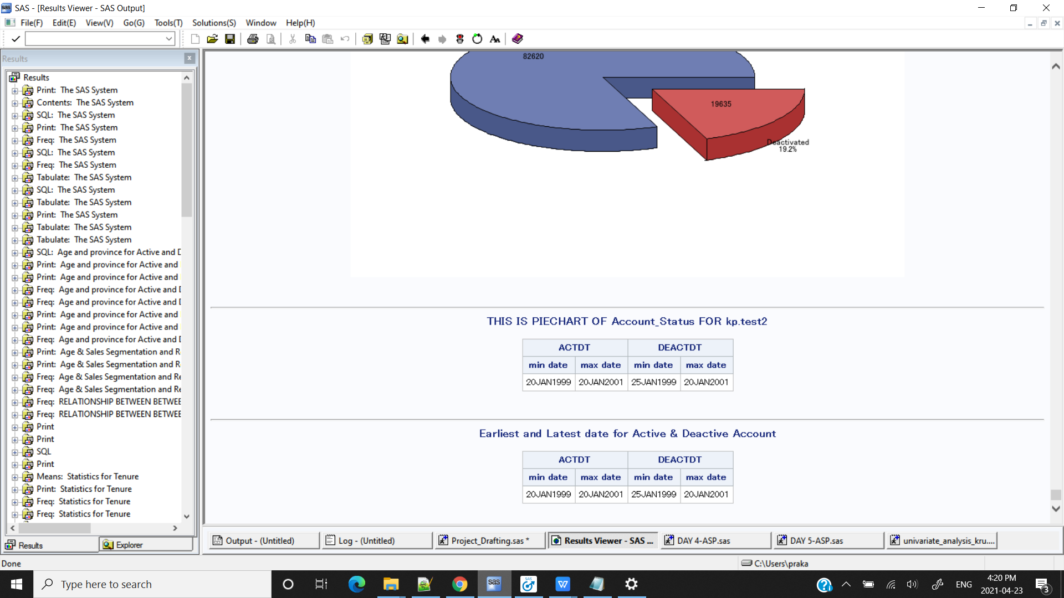

/*PROC SQL*/

**proc** **sql**;

select min(Actdt) as Earliest_Actdt format = date9. , max(Actdt) as Latest_Actdt format = date9. ,

min(Deactdt) as Earliest_Deactdt format = date9. , max(Deactdt) as Latest_Deactdt format = date9.

from kp.test2;

**quit**;

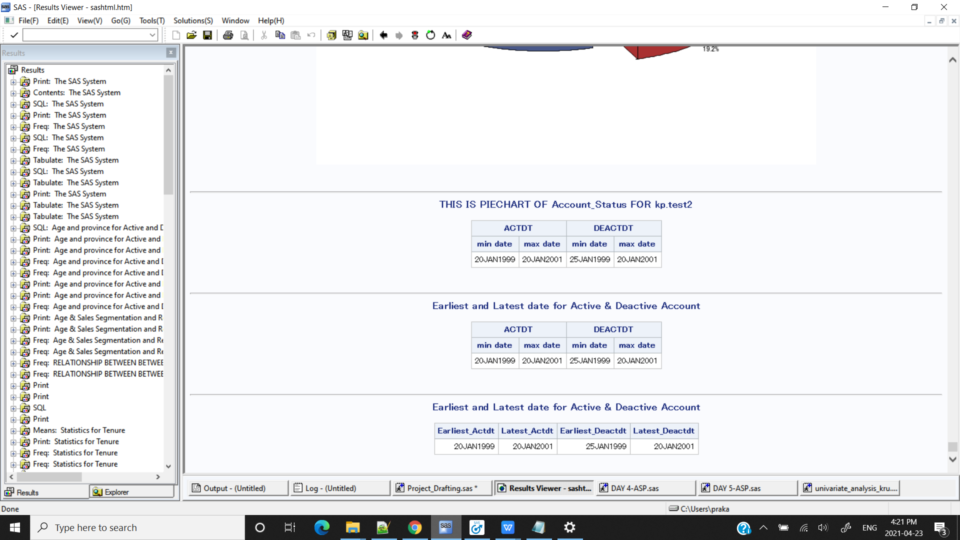

/*MACRO*/

**%macro** earliest_latest_date(DSN=,var1=,var2=);

proc tabulate data=&DSN. format=date9.;

var &var1 &var2;

table &var1=&var1*(min='min date' max='max date') &var2= &var2*(min='min date' max='max date') ;

run;

**%mend**;

%***earliest_latest_date***(DSN=kp.test2 ,var1=Actdt,var2=Deactdt);

title;

**\*\*\*\*\*\*\*\*\*\*\*\*\*\*\*\*\*\*\*\*\*\*\*\*\*\*\*\*\*\*\*\*\*\*\*\*\*\*\*\*\*\*\*\*\*\*\*\*\*\*\*\*\*\*\*\*\*\*\*\*\*\*\*\*\*\*\*\*\***

1.2 What is the age and province distributions of active and deactivated customers?

title'Age and Province distributions of active and deactivated customers';

**proc** **tabulate** data = kp.test2;

class Account_Status Province;

var Age;

Table Account_Status * Province,

Age * (Mean Median Mode) ;

**run**;

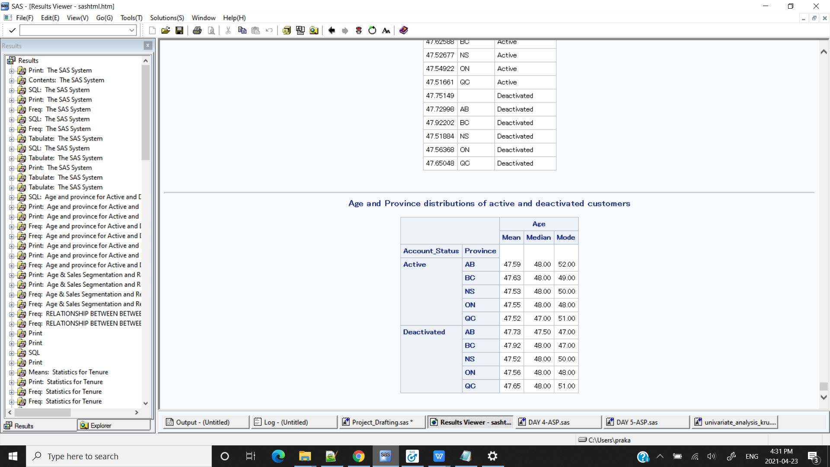

**proc** **sql**; /*PROC SQL */

title 'Age and province for Active and Deactivated Customers';

select mean(Age) as Age, Province,Account_Status

from kp.test2

group by Account_Status,Province;

**quit**;

title;

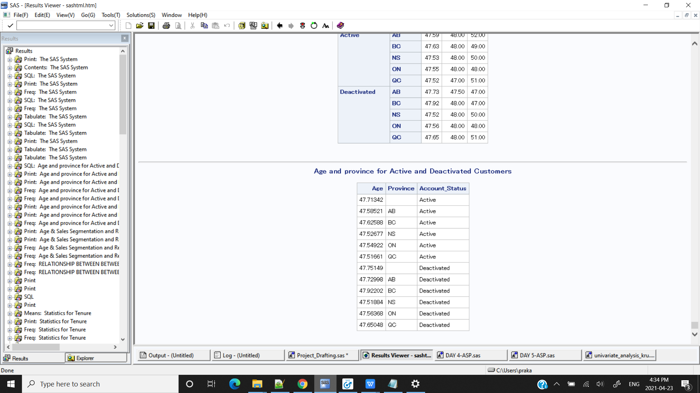

**/*CONCLUSION : There not much of difference of age across different provinces for activated and deactivated customers.It is observed that customers with age of 41 to 52 are occuring frequently in both the cases .ie. Active and Deactive\***

/**\*\*\*\*\*\*\*\*\*\*\*\*\*\*\*\*\*\*\*\*\*\*\*\*\*\*\*\*\*\*\*\*\*\*\*\*\*\*\*\*\*\*\*\*\*\*\*\*\*\*\*\*\*\*\*\*\*\*\*\*\*\*\*\*\*\*\*\*\***

/*1.3 Segment the customers based on age, province and sales amount:

Sales segment: < $100, $100---500, $500-$800, $800 and above.

Age segments: < 20, 21-40, 41-60, 60 and above.

Create analysis report */

title 'Age & Sales Segmentation and Report ';

**proc** **format**;

value agefmt

low-**20** = '<=20'

**21**-**40** = '21-40'

**41**-**60** ='41-60'

**61**-high = 'above 60'

;

**proc** **format**;

value Salesfmt

Low - **100** = "Very Low Sales"

**100** - **500** = "Low Sales"

**500** - **800** = "Moderate Sales"

**800** - high = "High Sales"

;

**run**;

**proc** **print** data= kp.test2(obs=**10**);

format Age agefmt. Sales_format Salesfmt. ;

**run**;

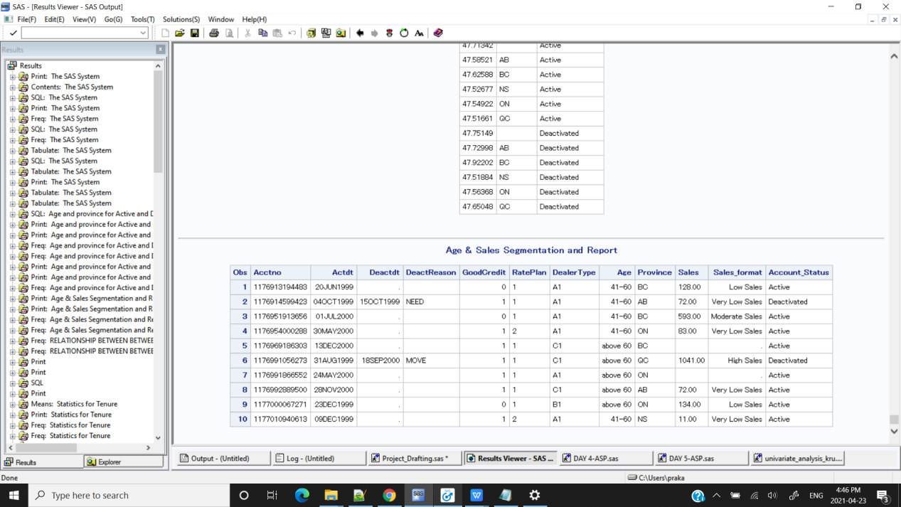

**/*Segmenting the data according to the bins given */**

/*To set the given format in data step so that we can use it as dataset to check the segments distribution for variable*/

**data** kp.test0;

set kp.test2;

format Age agefmt. Sales_format Salesfmt. ;

**run**;

**proc** **print** data=kp.test0(obs=**10**);**run**;

**proc** **freq** data=kp.test0;

tables Age;

**run**;

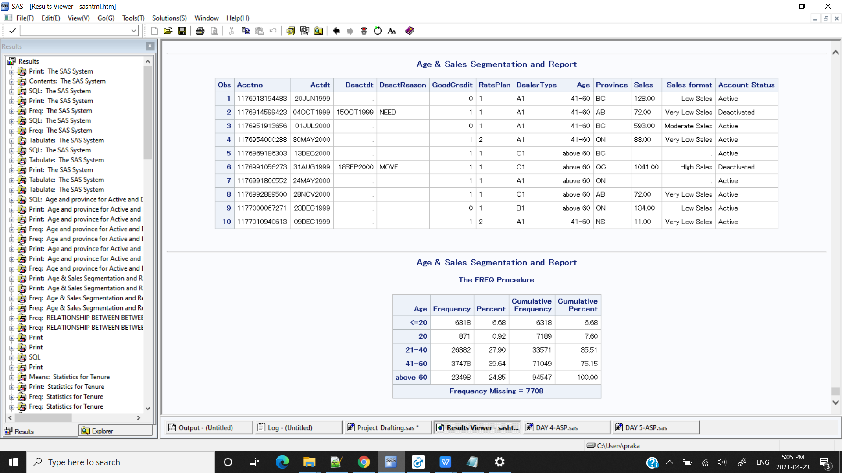

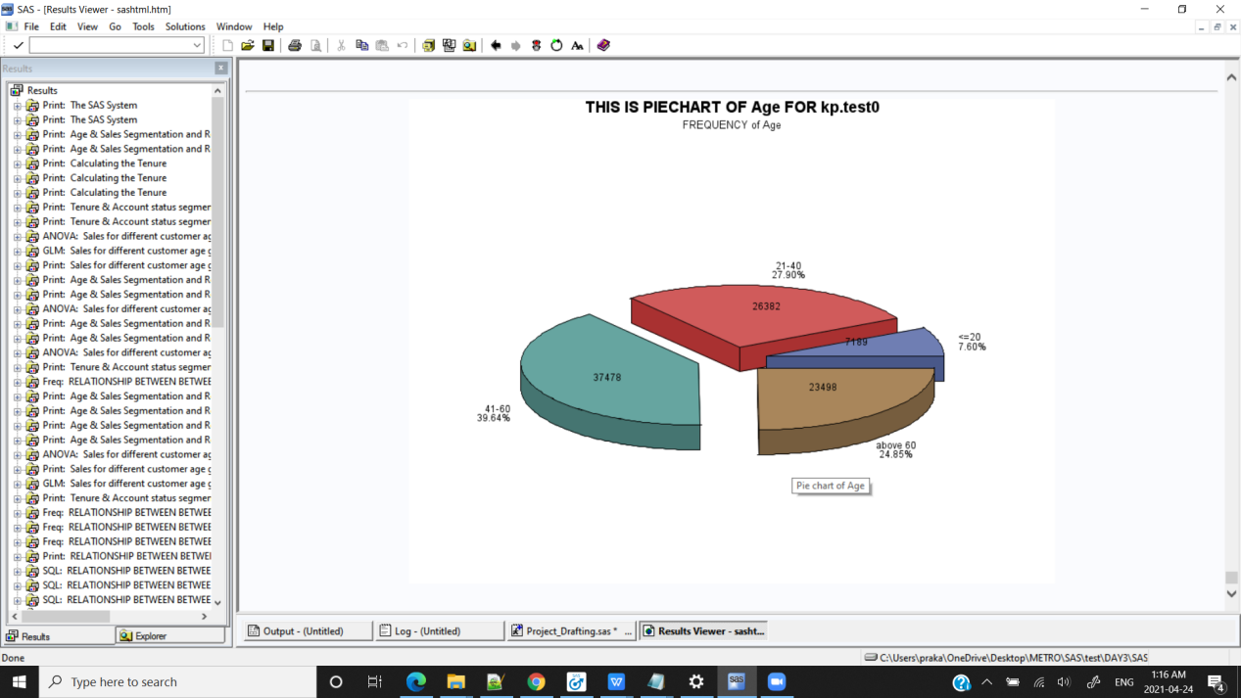

**/*CONCLUSION : Age group of 41-60 has highest number of customers*/**

**proc** **freq** data=kp.test0;

tables Sales_format;

**run**;

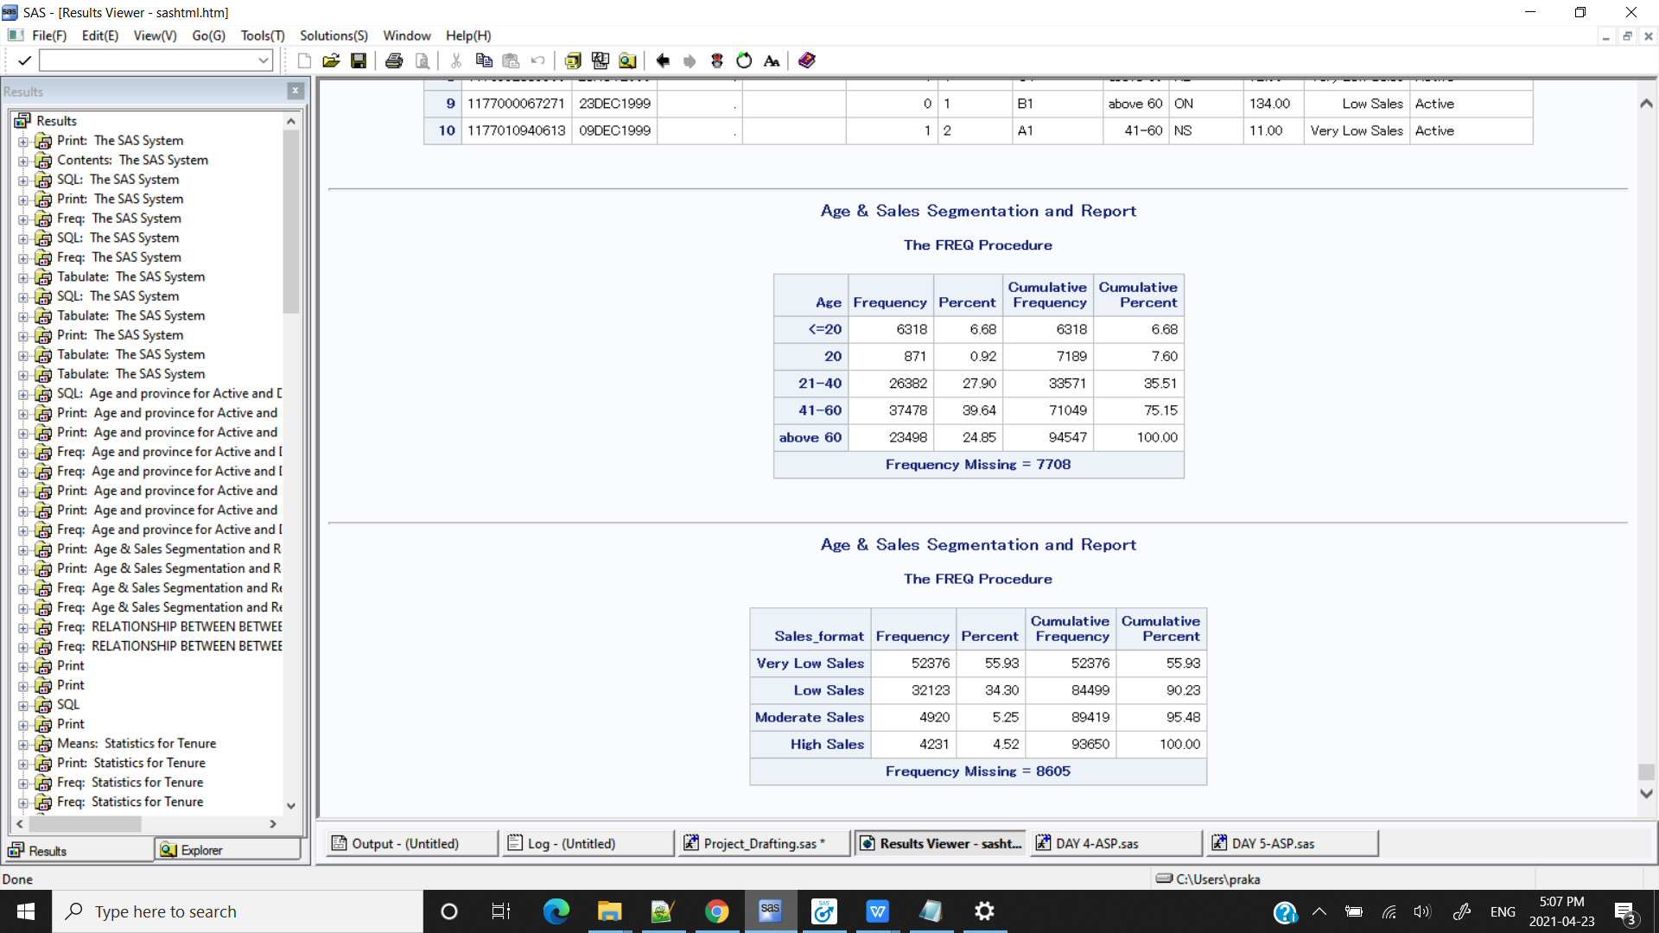

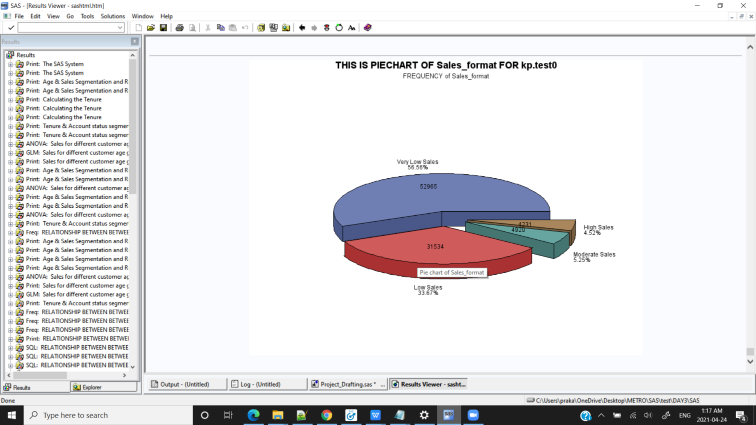

**/*CONCLUSION : Highest number of Sales is from Very low Sales group i.e. the amount of Sales is very low*/**

**proc** **freq** data=kp.test0;

tables Sales_format*Age;

**run**;

title;

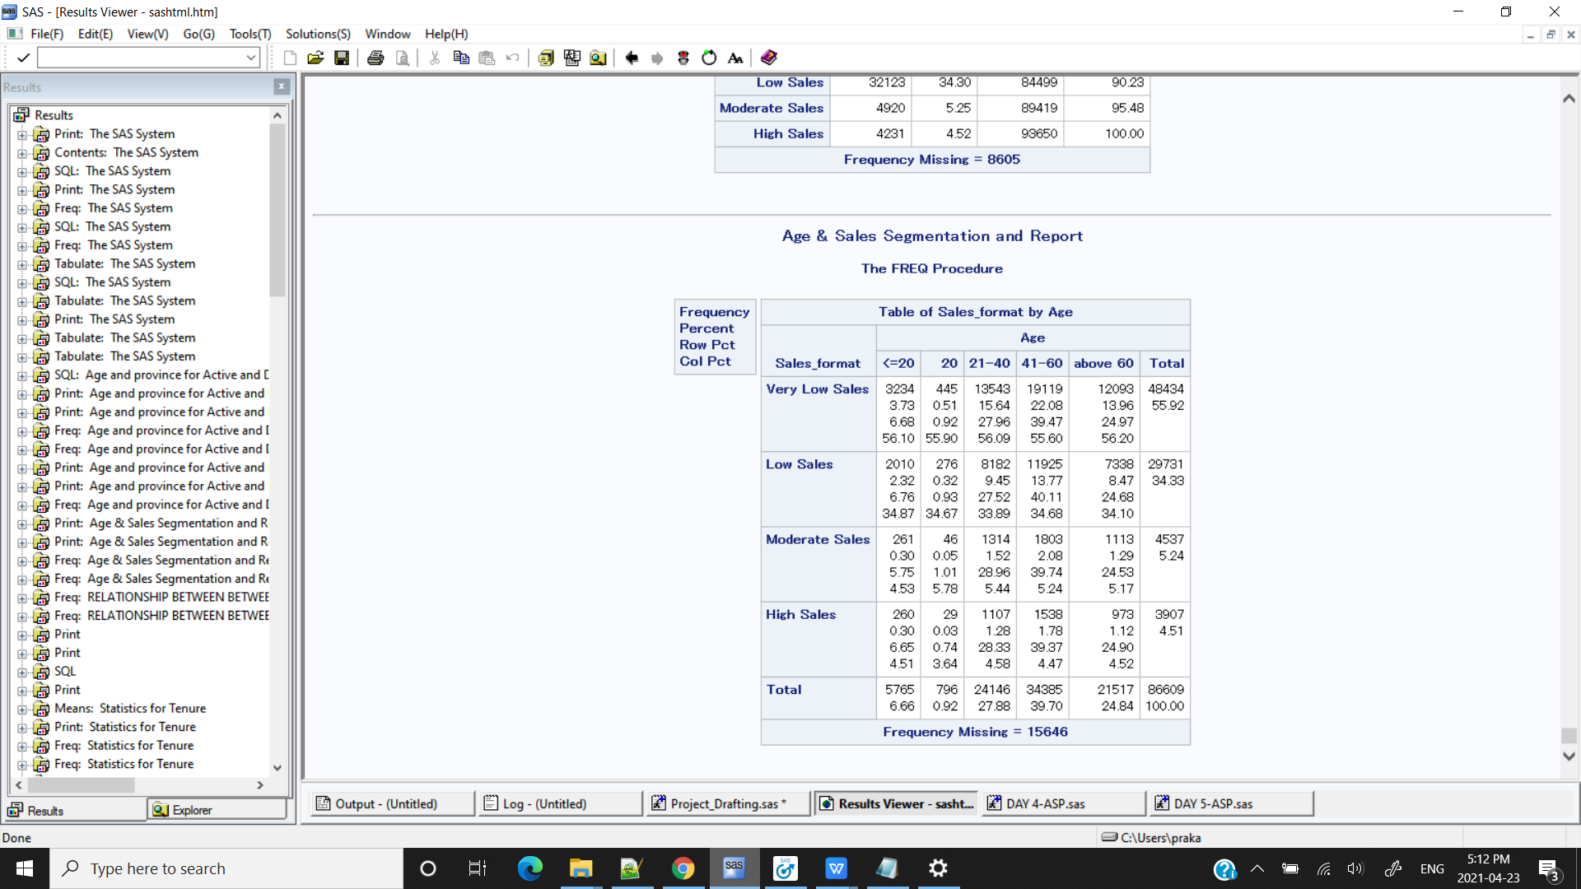

**PROC** **SGPLOT** DATA = kp.test0;

VBAR Age / GROUP = Sales_format;

TITLE 'Sales & Customer Age Segments';

**RUN**;

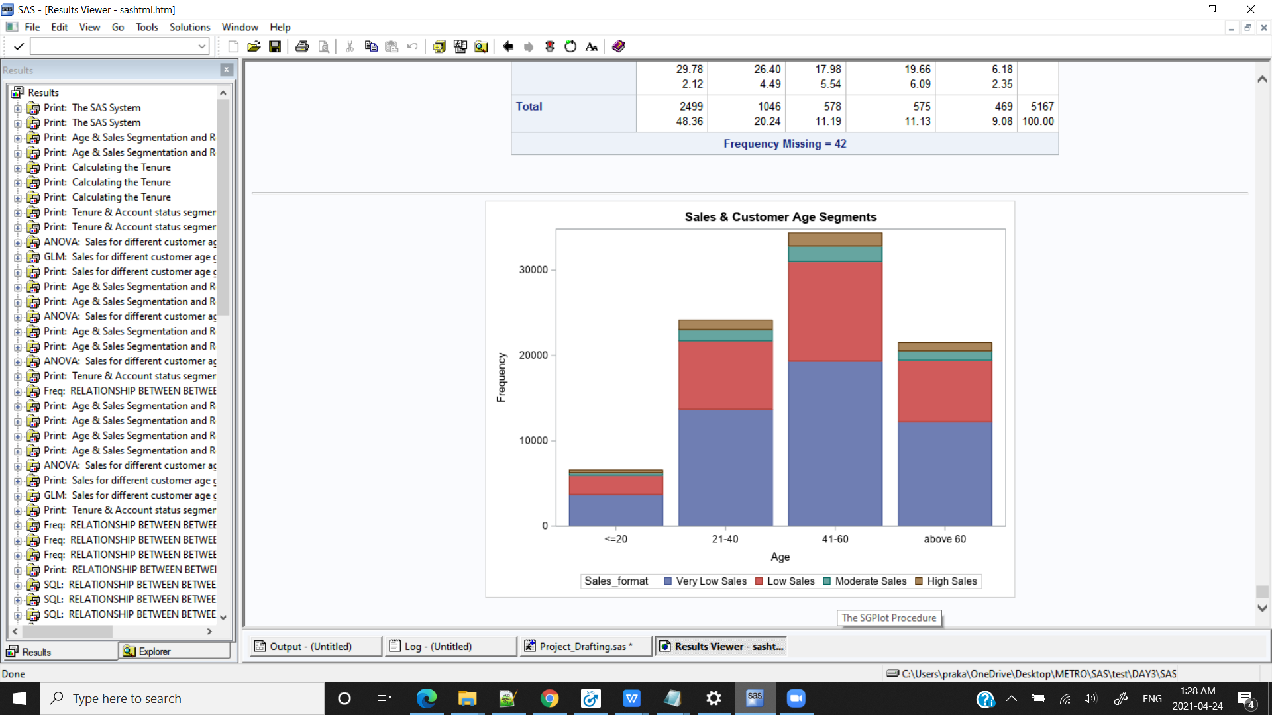

**/*CONCLUSION : From age segment it is observed that people from age group 41-60s are in high percent (i.e. 39.64%) than other groups**

**Highest number of Sales is from Very low sales group . It is observed that very low sales is observed in high percentage in the age group of 41-60*/**

/*

Null Hypothesis : There is no association between Age and Sales Segments.

Alternative Hypothesis : There is no association between Age and Sales Segments.

*/

**%MACRO** CHSQUARE (DSN = ,VAR1= , VAR2= );

PROC FREQ DATA = &DSN;

TITLE "RELATIONSHIP BETWEEN BETWEEN var1 AND var2";

TABLE &VAR1. * &VAR2 /CHISQ OUT=OUT_&VAR1._&VAR2 ;

RUN;

**%MEND** CHSQUARE;

%***CHSQUARE***(DSN = kp.test0 , VAR1= Sales_format , VAR2 = Age);

**/CONCLUSION: *Bivariate Analysis between the two categorical variables using Chi-square probability value is greater than significance level hence we accept the null Hypothesis there is no association between the two variables*/**

**\*\*\*\*\*\*\*\*\*\*\*\*\*\*\*\*\*\*\*\*\*\*\*\*\*\*\*\*\*\*\*\*\*\*\*\*\*\*\*\*\*\*\*\*\*\*\*\*\*\*\*\*\*\*\*\*\*\*\*\*\*\*\*\*\*\*\*\*\***

/*

1.4.Statistical Analysis:

1) Calculate the tenure in days for each account and give its simple statistics.*/

/*SAS Syntax*/

title'Calculating the Tenure';

**data** kp.test3;

set kp.test2;

dt=today();

format dt date9.;

if Deactdt =**.** then Deactdt = dt;

Tenure = INTCK("day",Actdt,Deactdt);

**run**;

**proc** **print** data = kp.test3(obs=**10**);**run**;

**/*Drop the dt variable for todays date*/**

**data** kp.test;

set kp.test3;

drop dt;

**run**;

**proc** **print** data = kp.test(obs=**10**);**run**;

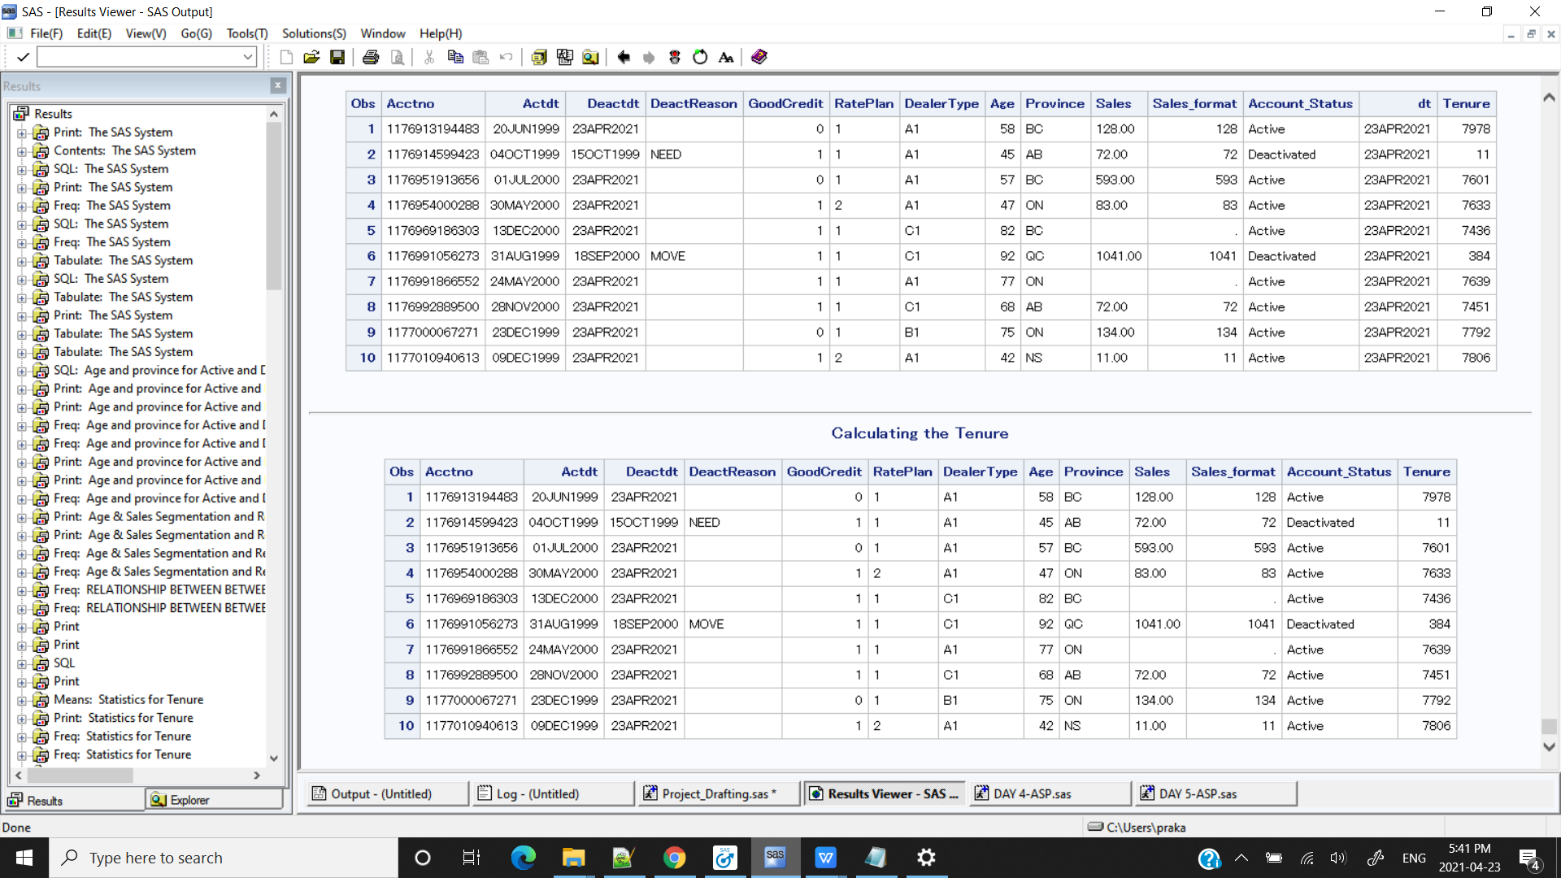

/*PROC SQL SYNTAX*/

**proc** **sql**;

select Actdt,Deactdt, intck('day', Actdt, Deactdt) as No_of_days

from kp.test(obs=**10**);

**quit**;

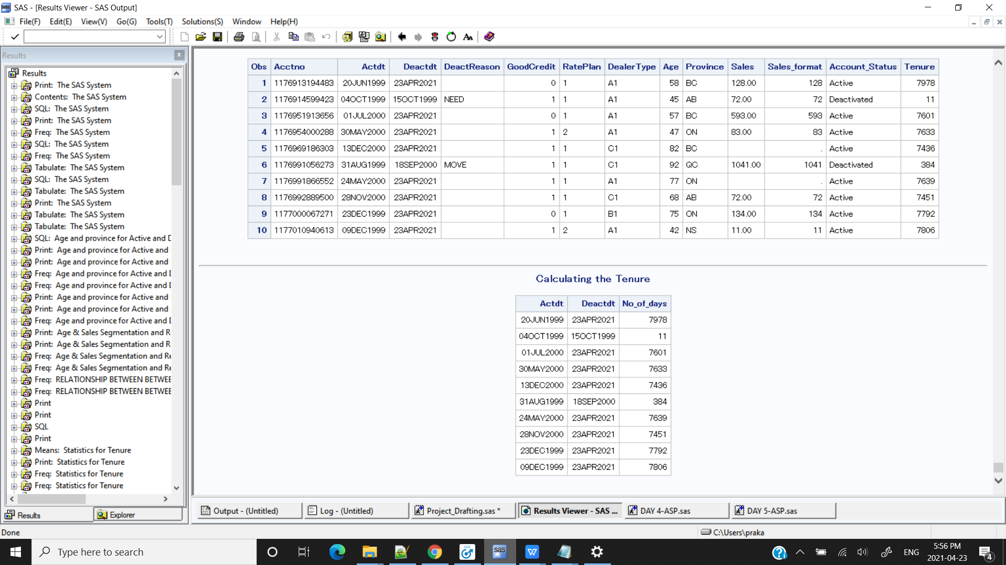

/*MACRO*/

**%macro** tenure(DSN=,var1=,var2=,var3=);

proc sql;

select &var1,&var2, intck('day', &var1, &var2) as No_of_days

from &DSN(obs=**10**);

quit;

**%mend**;

%***tenure***(DSN=kp.test,var1=Actdt,var2=Deactdt);



**proc** **means** data=kp.test3 n mean median mode max min range std fw=**8**;

var Tenure ;

title 'Statistics for Tenure';

**run**;

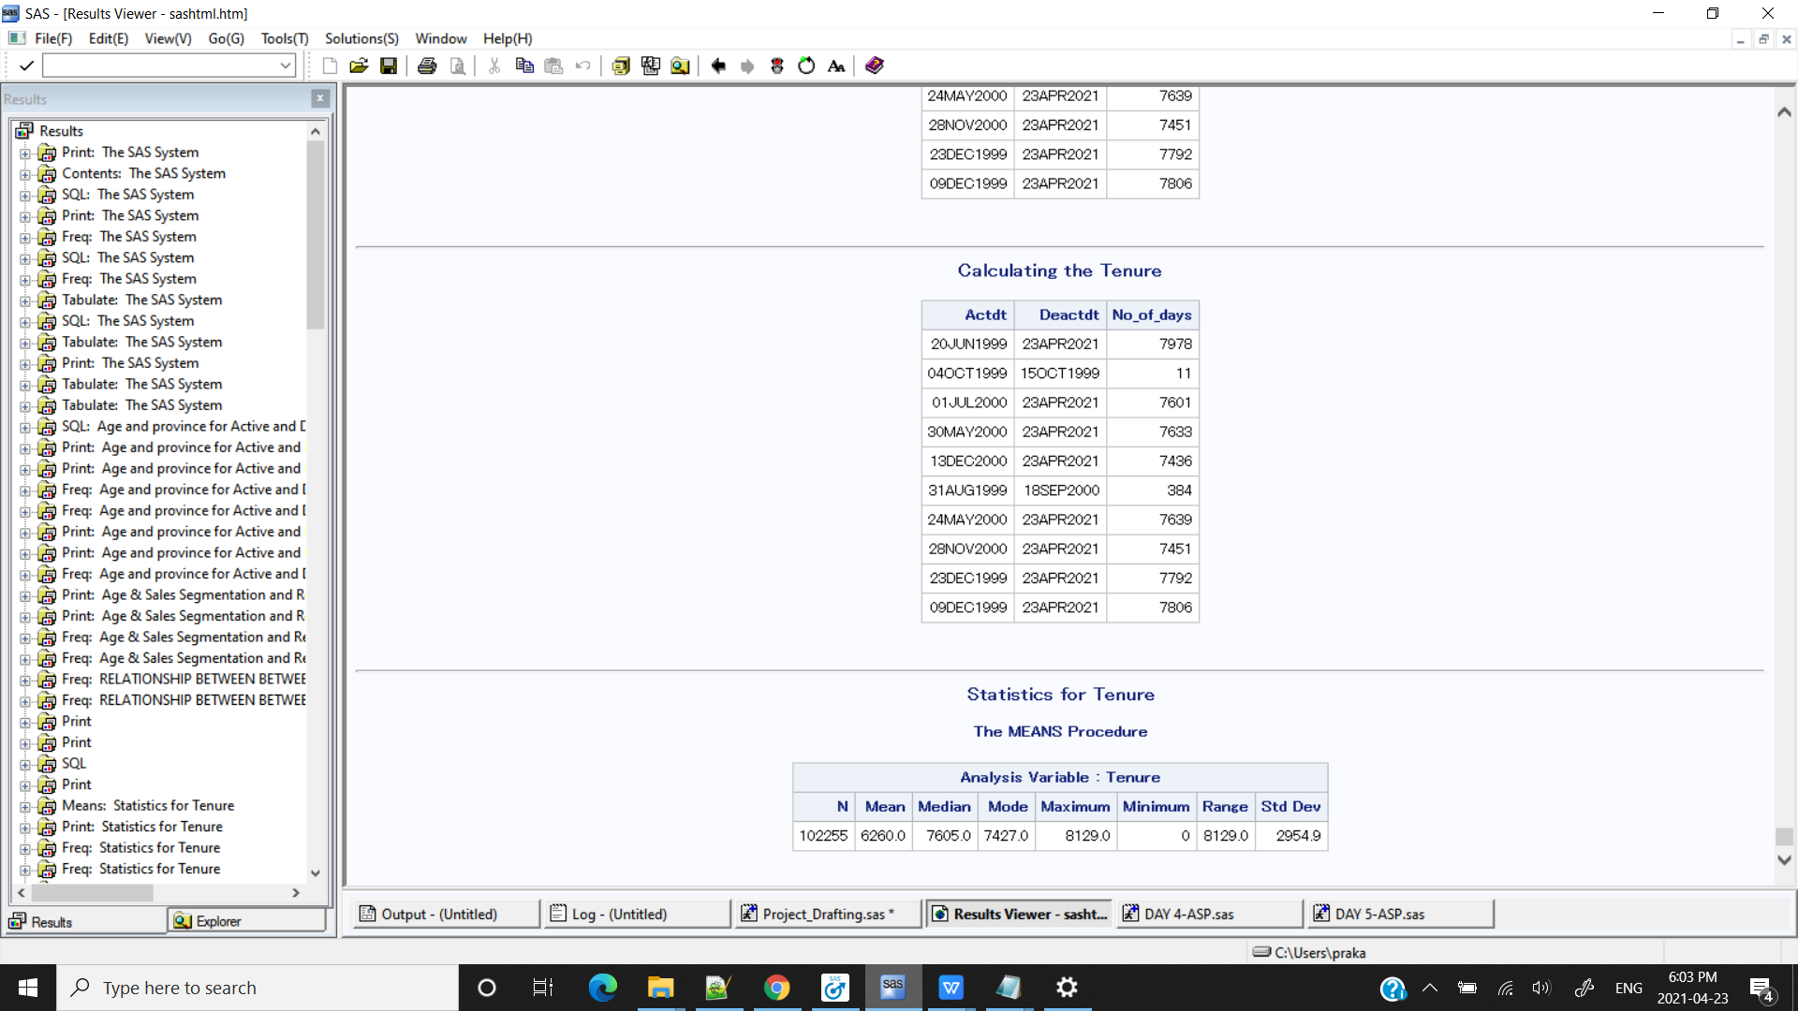

%***UNI_ANALYSIS_NUM***(kp.test,Tenure)

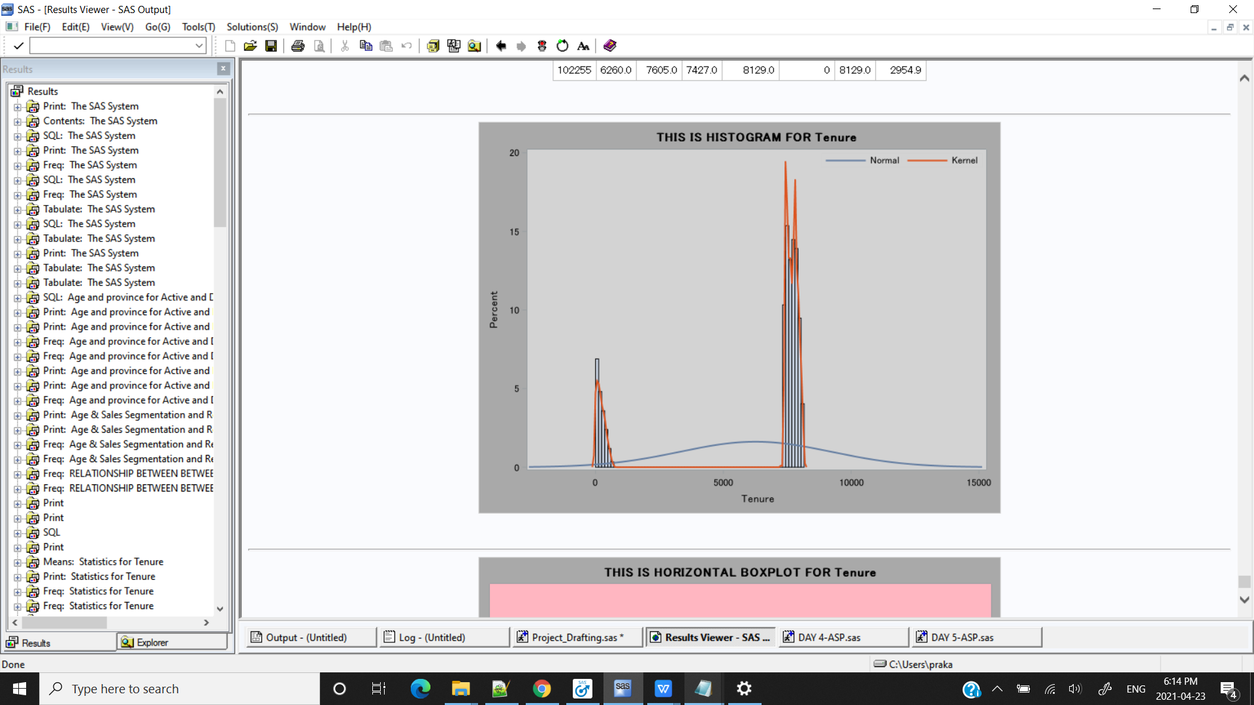

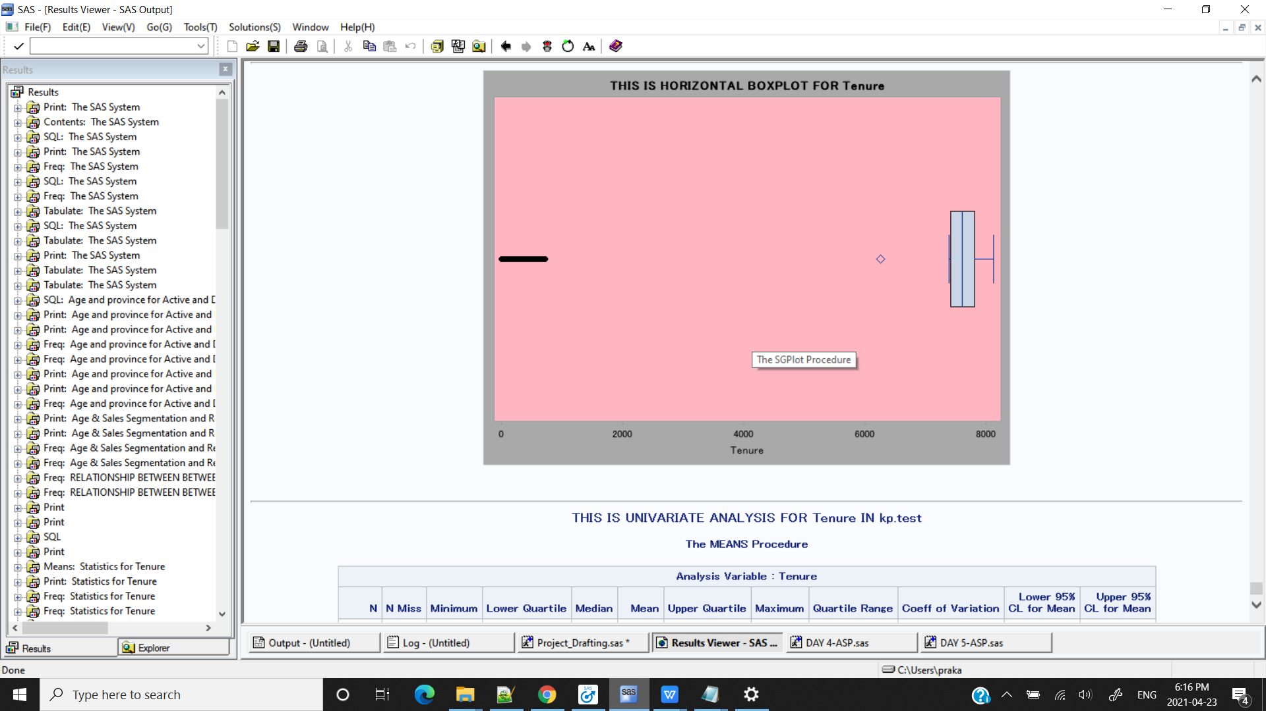

**/*CONCLUSION : Outliers are mostly from deactivated account. If customers passes a particular threshold then we can prevent the churn rate for that we have to retain the customers either with good service(taking feedback) or good offers*/**

**\*\*\*\*\*\*\*\*\*\*\*\*\*\*\*\*\*\*\*\*\*\*\*\*\*\*\*\*\*\*\*\*\*\*\*\*\*\*\*\*\*\*\*\*\*\*\*\*\*\*\*\*\*\*\*\*\*\*\*\*\*\*\*\*\*\*\*\*\*\*\*\*\*\*\*\*\*\*\*\*\*\*\*\*\*\*\*\***

/*2) Calculate the number of accounts deactivated for each month.*/

/*SAS SYNTAX*/

/*To classify Accounts based on months*/

title 'Deactivated accounts for each month.';

**data** kp.test4;

set kp.test2;

if Deactdt =**.** then

month = intnx('month',Actdt,**0**,'b');

format month monname3. ;

else

month = intnx('month',Deactdt,**0**,'b');

format month monname3. ;

**run**;

**proc** **print** data = kp.test4(obs=**10**);**run**;

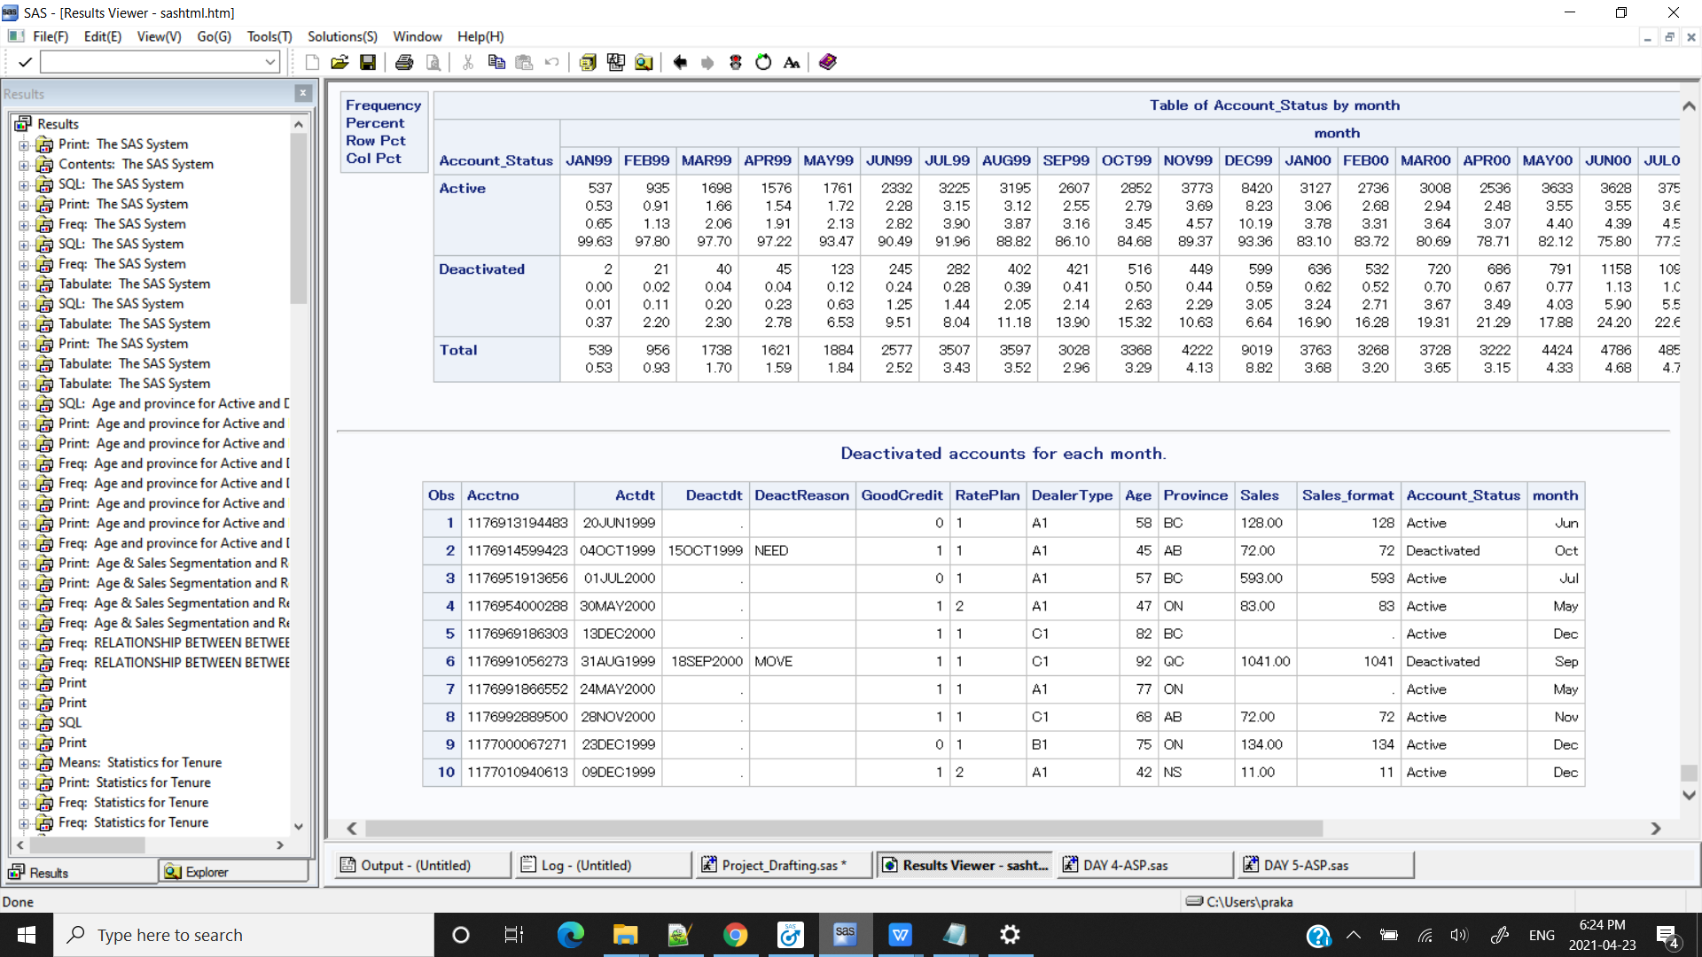

**proc** **freq** data = kp.test4;

tables Account_Status*month;

**run**;

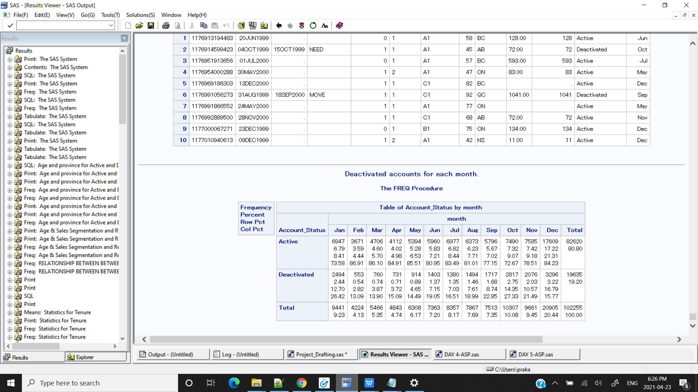

/*PROC SQL*/

**proc** **sql**;

select month, count(month)

from kp.test4

where Account_Status = "Deactivated"

group by month

;

**quit**;

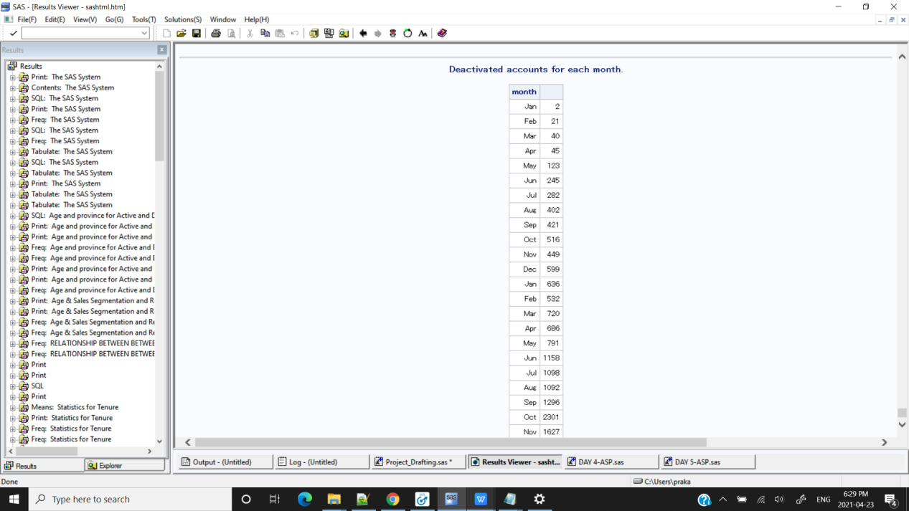

**/*CONCLUSION : Proc sql gives distribution of Deactive accounts for each month for every year hence there are 25 rows for 2 years data It won't give distinct for months as month is extracted from date*/**

/*MACRO*/

**%macro** levels_two_variable(DSN=,var1=,var2=);

proc freq data= &DSN. ;

tables &var1*&var2;

run;

**%mend**;

%***levels_two_variable***(DSN=kp.test4,var1=Account_Status,var2=month);



**/*CONCLUSION : Highest percent of churn rate is observed in the month of December & also in month of October November & January.**

**RECOMMENDATION : Retaining the customers before last quarter of the year by giving special offers or taking feedbacks for services.*/**

**\*\*\*\*\*\*\*\*\*\*\*\*\*\*\*\*\*\*\*\*\*\*\*\*\*\*\*\*\*\*\*\*\*\*\*\*\*\*\*\*\*\*\*\*\*\*\*\*\*\*\*\*\*\*\*\*\*\*\*\*\*\*\*\*\*\*\*\*\*\*\*\*\*\*\*\*\*\*\*\*\*\*\*\*\*\*\***

/*3) Segment the account, first by account status Active・and Deactivated・ then by

Tenure: < 30 days, 31---60 days, 61 days--- one year, over one year. Report the

number of accounts of percent of all for each segment.*/

/*SAS SYNTAX*/

title'Tenure & Account status segmentation';

**proc** **format**;

value $account_status

'Active'='Active'

'Deactivated'='Deactive'

;

**proc** **format**;

value tenurefmt

low-<**30**='<30'

**31**- <**60**='31-60'

**61**- <**365**='6mon-1yr'

**366**-high='>1yr'

; **run**;

**data** kp.test5;

set kp.test;

format Account_Status $account_status. Tenure tenurefmt. ;

**run**;

**proc** **print** data=kp.test5(obs=**10**);**run**;

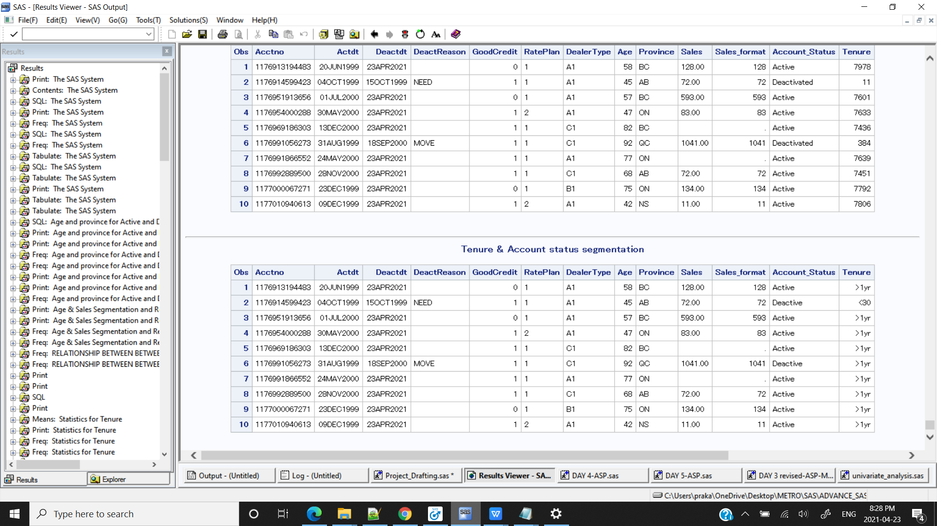

**proc** **freq** data = kp.test5;

tables Tenure*Account_Status;

**run**;

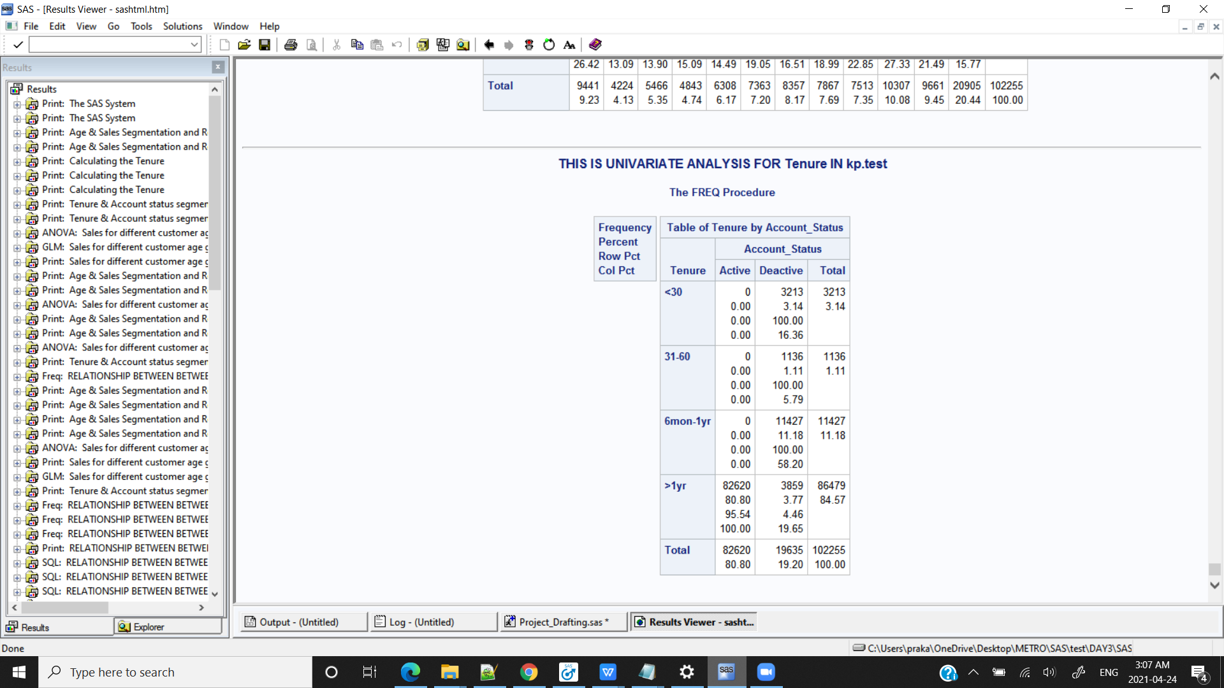

/*MACRO SYNTAX*/

%***levels_variable***(DSN=kp.test5,var1=Tenure);

%***levels_two_variable***(DSN=kp.test5,var1=Account_Status,var2=Tenure);

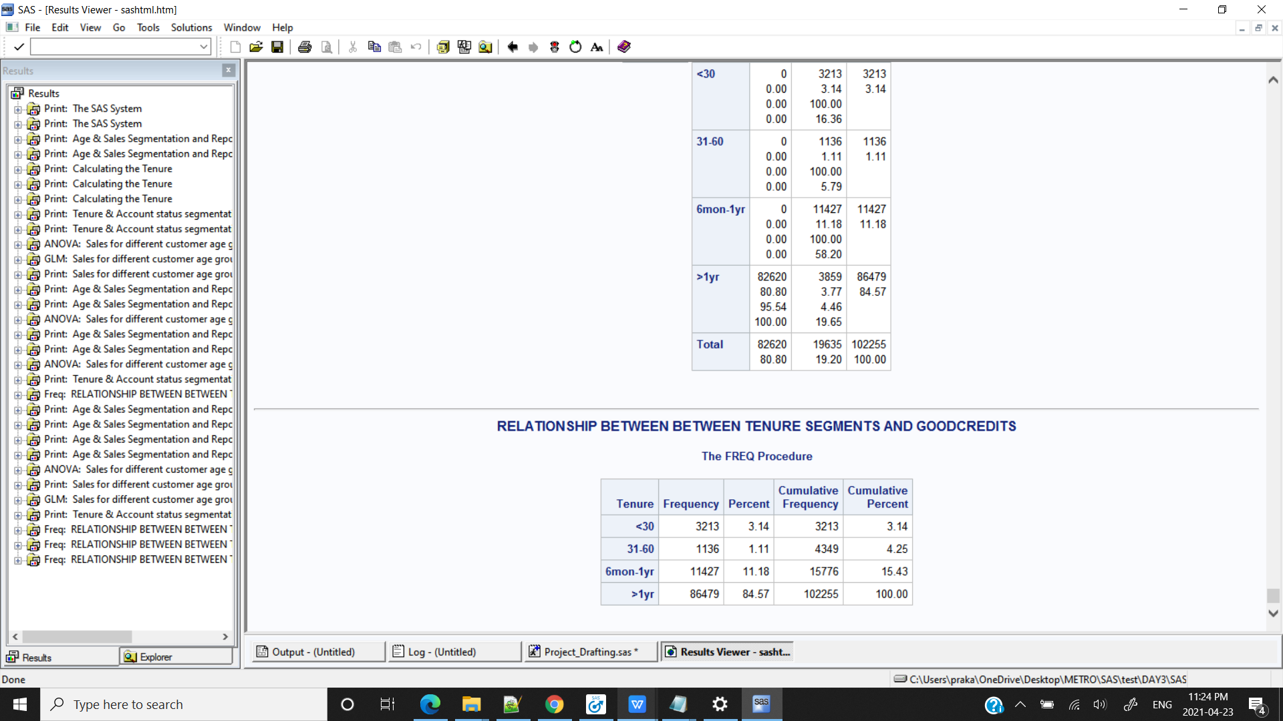

Title;

/*MACRO SYNTAX*/

%***levels_variable***(DSN=kp.test5,var1=Tenure);

%***levels_two_variable***(DSN=kp.test5,var1=Account_Status,var2=Tenure);



%***UNI_ANALYSIS_CAT_FORMAT***(kp.test5,TENURE,tenurefmt.)

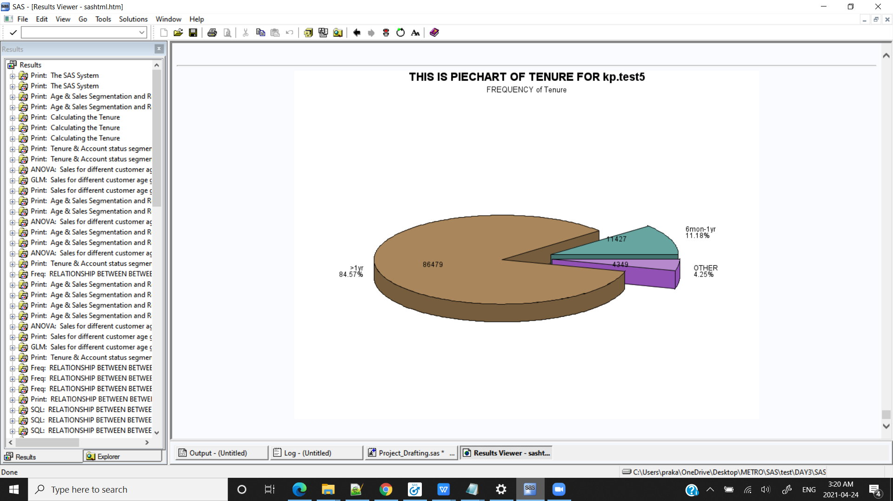

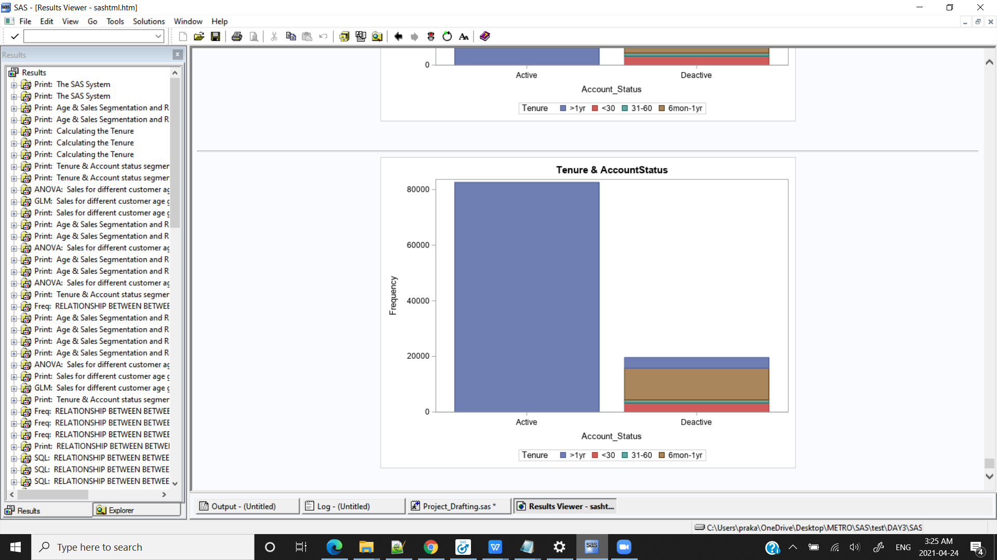

**/*CONCLUSION : There are high percentage of customers discontinuing the service within 6 months to one year,if they are continuing beyond one year chances of churning out is very low.*/**

**\*\*\*\*\*\*\*\*\*\*\*\*\*\*\*\*\*\*\*\*\*\*\*\*\*\*\*\*\*\*\*\*\*\*\*\*\*\*\*\*\*\*\*\*\*\*\*\*\*\*\*\*\*\*\*\*\*\*\*\*\*\*\*\*\*\*\*\***

/*4) Test the general association between the tenure segments and Good Credit・

RatePlan ・and DealerType.*/

/*TENURE SEGMENTS AND GOODCREDITS*/

/*SAS SYNTAX*/

/*Null Hypothesis : There is no association between Tenure segments and Goodcredits

Alternate Hypothesis: There is association between Tenure segments and Goodcredits */

**PROC** **FREQ** DATA = kp.test5;

TITLE "RELATIONSHIP BETWEEN BETWEEN TENURE SEGMENTS AND GOODCREDITS";

TABLE GoodCredit* TENURE/CHISQ OUT=OUT_BP_STATUS;

**RUN**;

/*MACRO*/

**%MACRO** CHSQUARE (DSN = ,VAR1= , VAR2= );

PROC FREQ DATA = &DSN;

TITLE "RELATIONSHIP BETWEEN BETWEEN var1 AND var2";

TABLE &VAR1. * &VAR2 /CHISQ OUT=OUT_&VAR1._&VAR2 ;

RUN;

**%MEND** CHSQUARE;

%***CHSQUARE***(DSN = kp.test5 , VAR1= GoodCredit , VAR2 =TENURE);

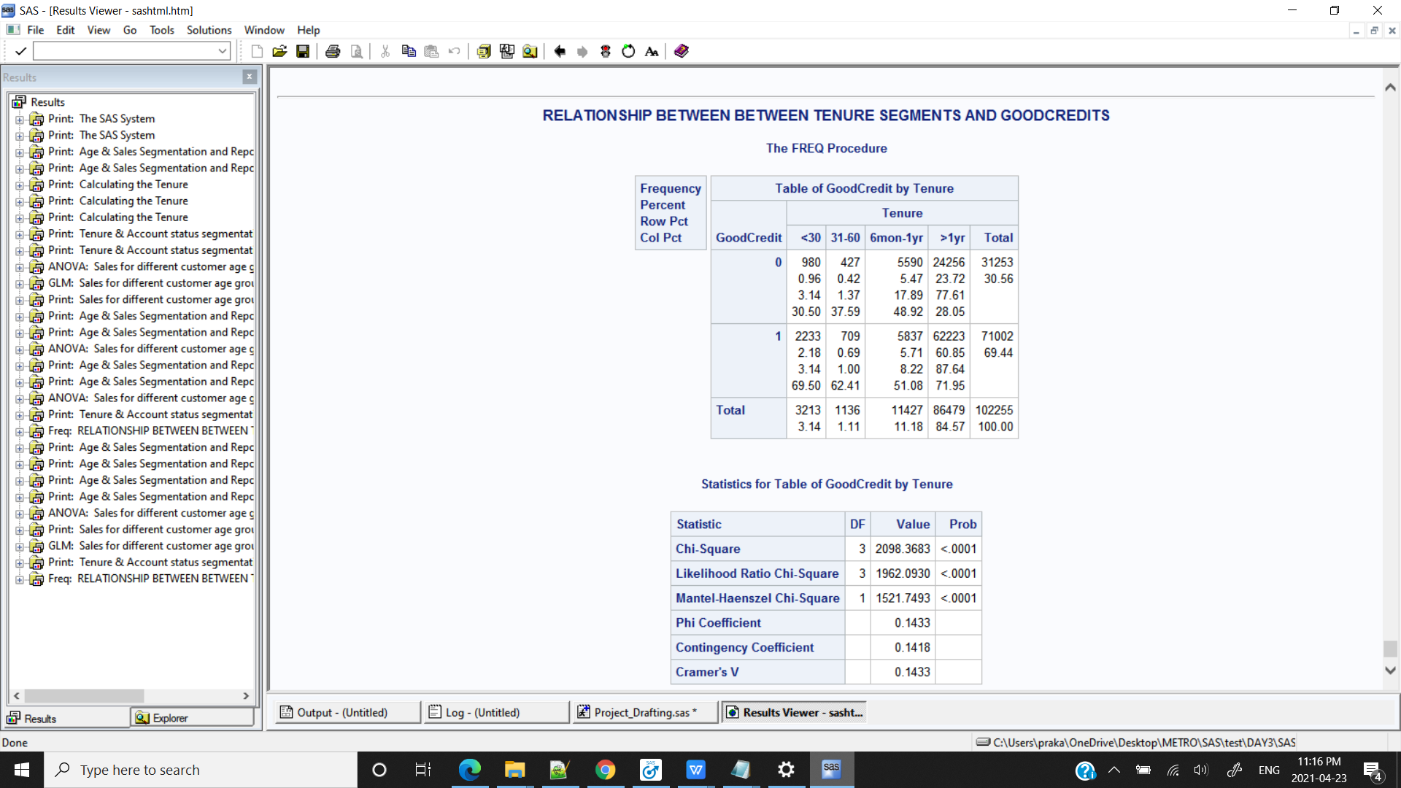

**/*CONCLUSION: Here the p-value is 0.001 which is less than significance level hence we reject the Null Hypothesis.There is some association between tenure segments and Goodcredits*/**

/* RATEPLAN AND DEALERTYPE*/

/*SAS SYNTAX*/

/*Null Hypothesis : There is no association between Rateplan and Dealertype

Alternate Hypothesis: There is association between Rateplan and Dealertype */

**PROC** **FREQ** DATA = kp.test5;

TITLE "RELATIONSHIP BETWEEN BETWEEN RATEPLAN AND DEALERTYPE";

TABLE RatePlan*DealerType /CHISQ OUT=OUT_BP_STATUS;

**RUN**;

/*MACRO*/

**%MACRO** CHSQUARE (DSN = ,VAR1= , VAR2= );

PROC FREQ DATA = &DSN;

TITLE "RELATIONSHIP BETWEEN BETWEEN var1 AND var2";

TABLE &VAR1. * &VAR2 /CHISQ OUT=OUT_&VAR1._&VAR2 ;

RUN;

**%MEND** CHSQUARE;

%***CHSQUARE***(DSN = kp.test6 , VAR1= Rateplan , VAR2 =DealerType);

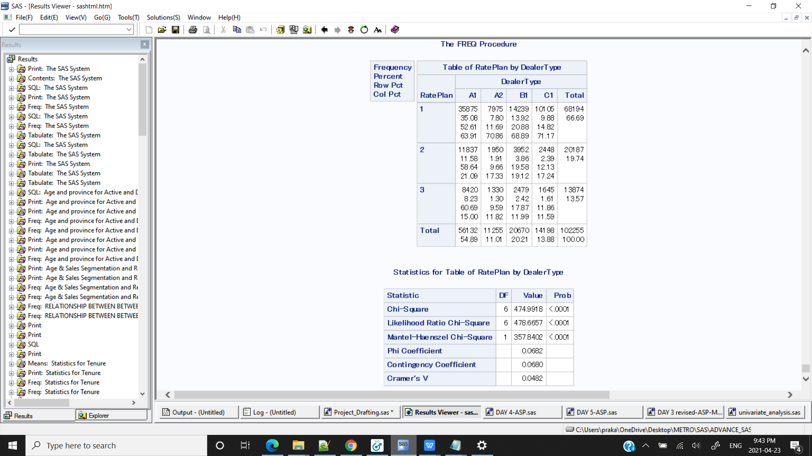

**/*CONCLUSION: Here the p-value is 0.001 which is less than significance level hence we reject the Null Hypothesis.There is some association between Rateplan and Dealertype*/**

**\*\*\*\*\*\*\*\*\*\*\*\*\*\*\*\*\*\*\*\*\*\*\*\*\*\*\*\*\*\*\*\*\*\*\*\*\*\*\*\*\*\*\*\*\*\*\*\*\*\*\*\*\*\*\*\*\*\*\*\*\*\*\*\*\*\*\*\***

/*5) Is there any association between the account status and the tenure segments?*/

/*SAS SYNTAX*/

**PROC** **FREQ** DATA = kp.test6;

TITLE "RELATIONSHIP BETWEEN BETWEEN ACCOUNT STATUS AND TENURE SEGMENTS";

TABLE Account_Status* TENURE/CHISQ OUT=OUT_BP_STATUS;

**RUN**;

/*MACRO*/

**%MACRO** CHSQUARE (DSN = ,VAR1= , VAR2= );

PROC FREQ DATA = &DSN;

TITLE "RELATIONSHIP BETWEEN BETWEEN var1 AND var2";

TABLE &VAR1. * &VAR2 /CHISQ OUT=OUT_&VAR1._&VAR2 ;

RUN;

**%MEND** CHSQUARE;

%***CHSQUARE***(DSN = kp.test6 , VAR1= Account_Status , VAR2 =TENURE);

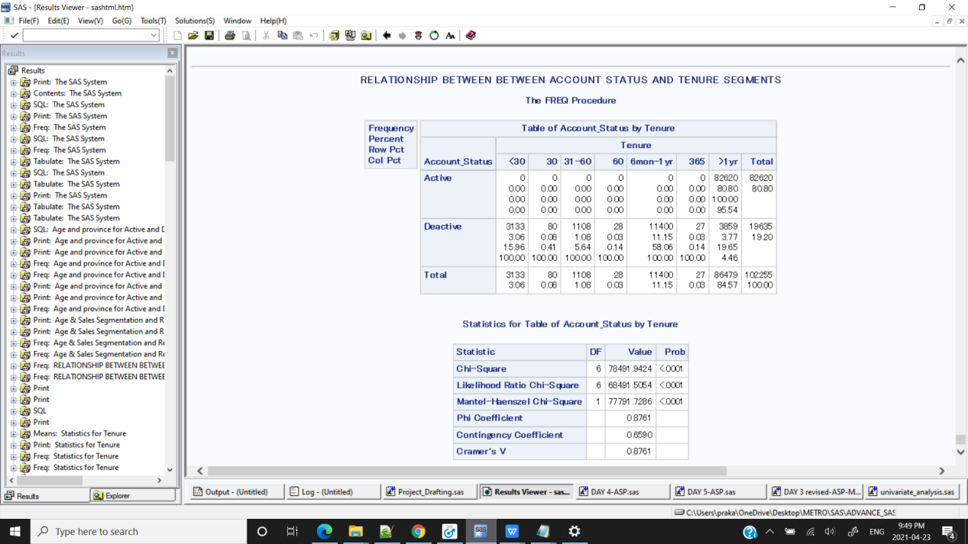

**/*CONCLUSION: Here the p-value is 0.001 which is less than significance level hence we reject the Null Hypothesis.There is some association between AccountStatus and Tenure*/**

**\*\*\*\*\*\*\*\*\*\*\*\*\*\*\*\*\*\*\*\*\*\*\*\*\*\*\*\*\*\*\*\*\*\*\*\*\*\*\*\*\*\*\*\*\*\*\*\*\*\*\*\*\*\*\*\*\*\*\*\*\*\*\*\*\*\*\*\***

/* 6) Does Sales amount differ among different account status, GoodCredit, and

customer age segments?*/

/*SAS SYNTAX*/

/*SALES & ACCOUNT STATUS*/

/*

Null Hypothesis : There is no association between Sales and Accout Status

Alternative Hypothesis: There is some association between Sales and Accout Status

*/

ods graphics on;

**proc** **ttest** data=kp.test2;

class Account_Status;

var Sales_format;

**run**;

ods graphics off;

/*MACRO SYNTAX*/

**%macro** ttest_var_class(DSN=,var1=,var2=);

ods graphics on;

proc ttest data=&DSN.;

class &var1;

var &var2;

ods graphics off;

**%mend**;

%***ttest_var_class***(DSN=kp.test2,var1=Account_Status,var2=Sales_format);

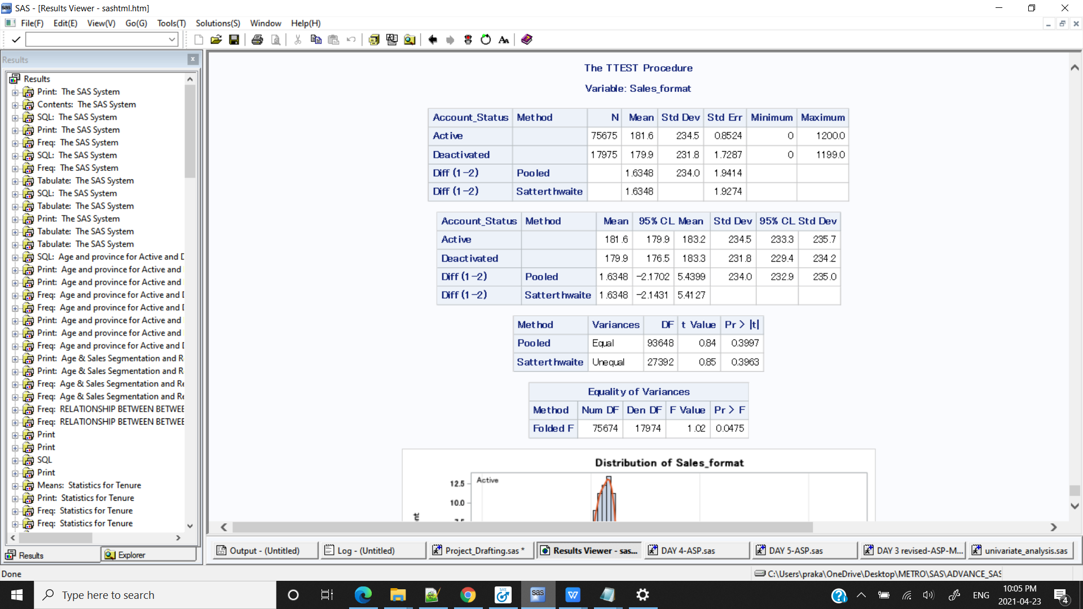

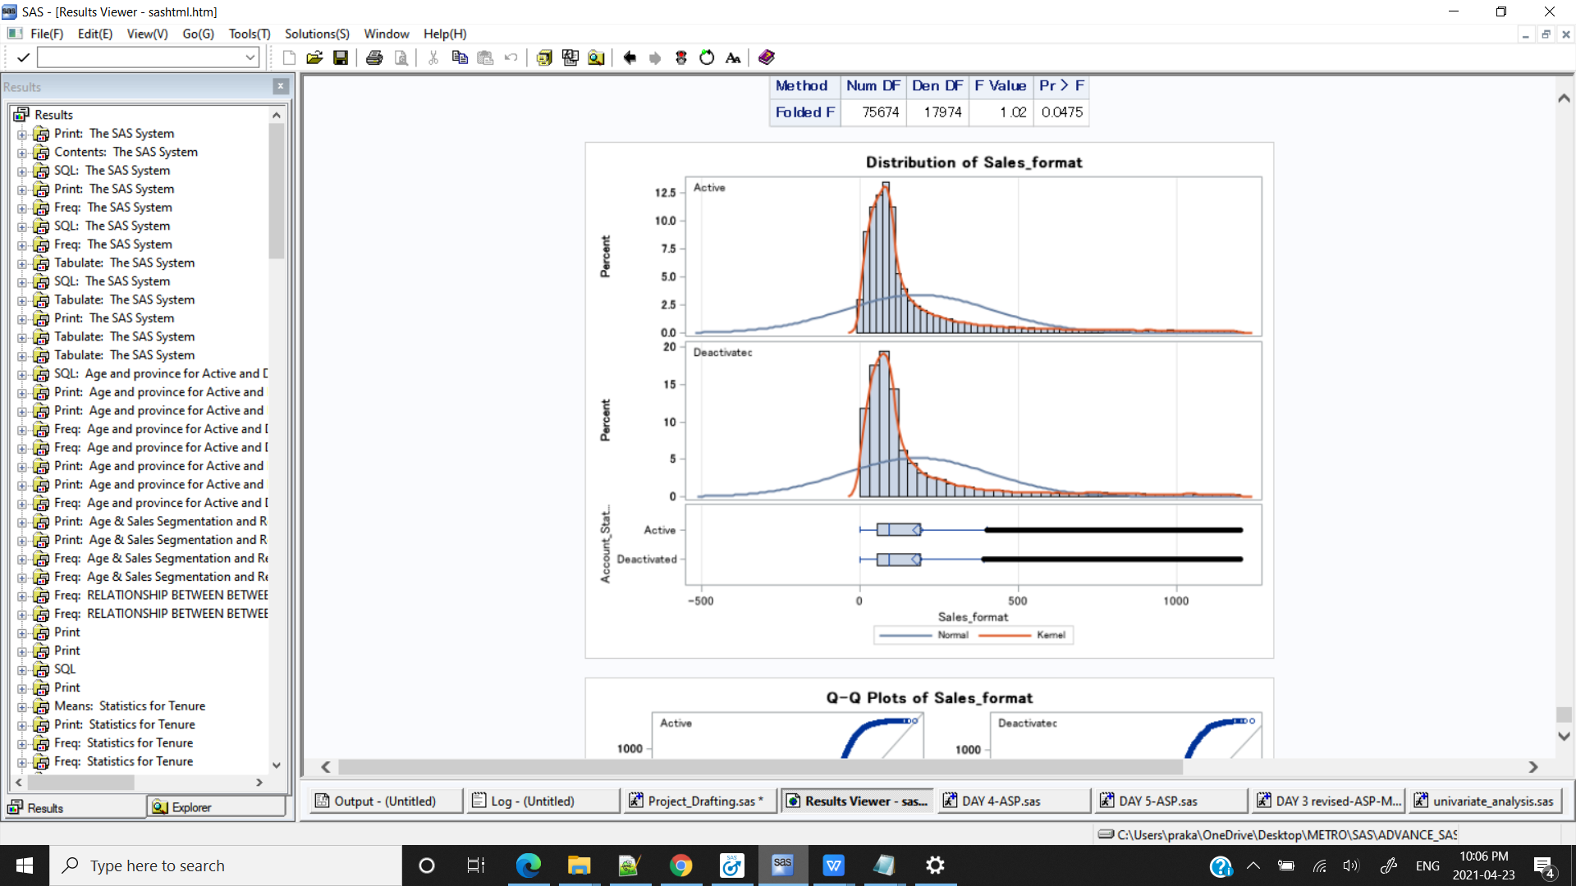

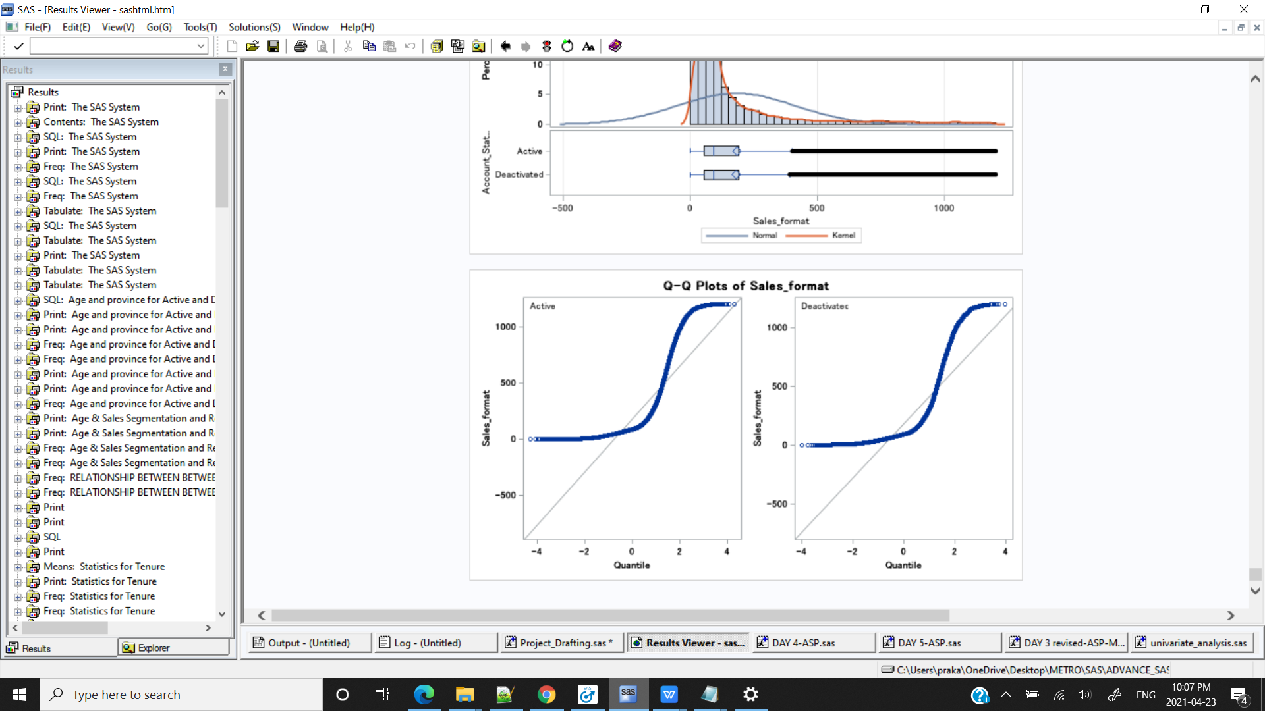

**/*CONCLUSION: Here the p-value is 0.0475 which is less than significance level hence we reject the Null Hypothesis.There is some association between Sales and Account Status(but weak association as value ia very close to 0.05)*/**

/*SAS SYNTAX*/

/*SALES & GOODCREDIT*/

/*

Null Hypothesis : There is no association between Sales and Goodcredit

Alternative Hypothesis: There is association between Sales and Goodcredit

*/

ods graphics on;

**proc** **ttest** data=kp.test2;

class GoodCredit;

var Sales_format;

**run**;

ods graphics off;

%***ttest_var_class***(DSN=kp.test2,var1=GoodCredit,var2=Sales_format);

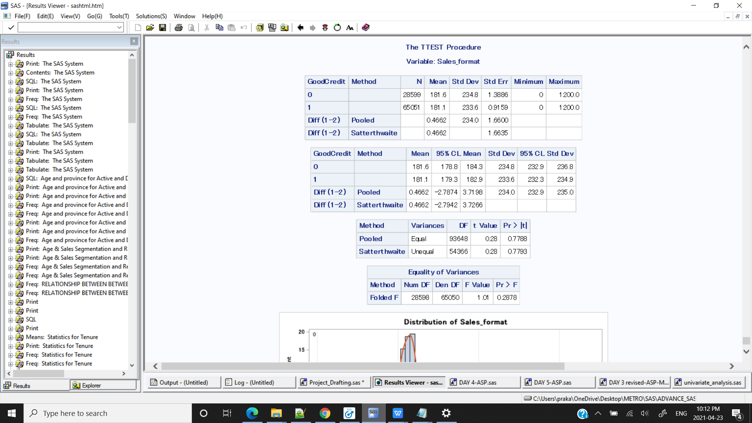

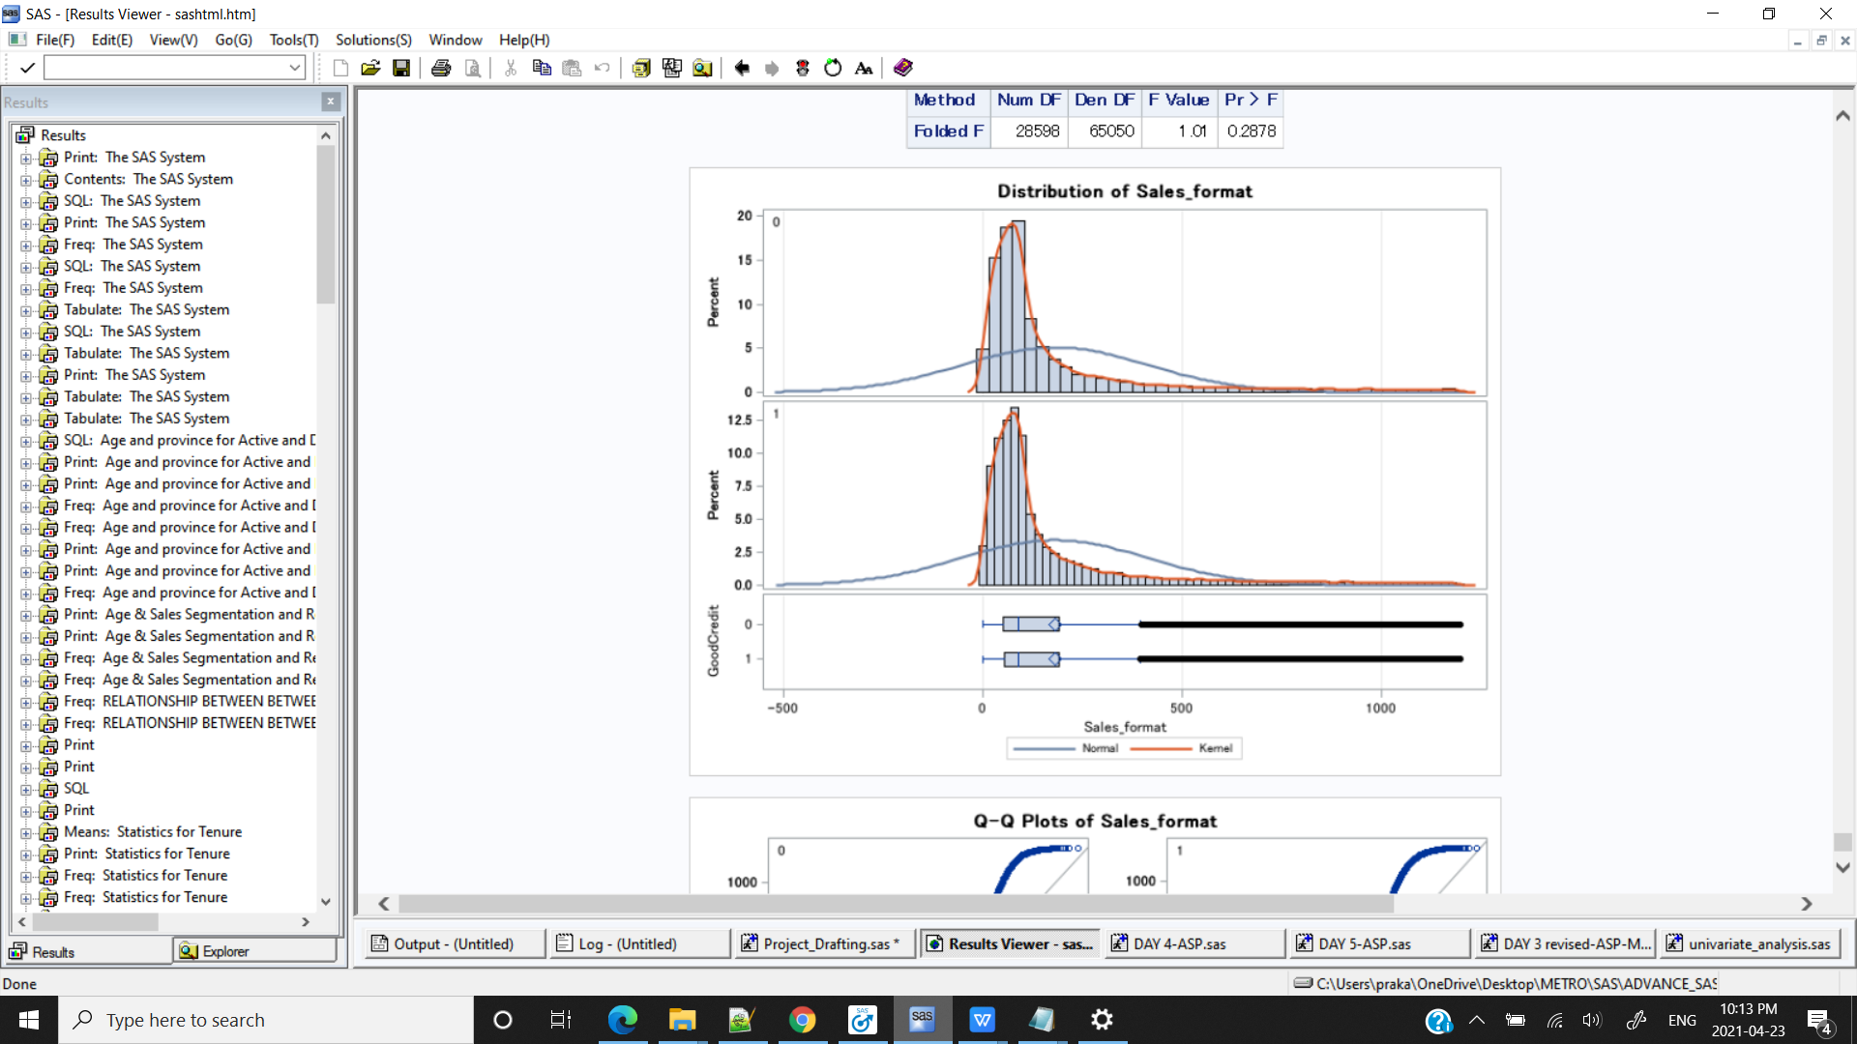

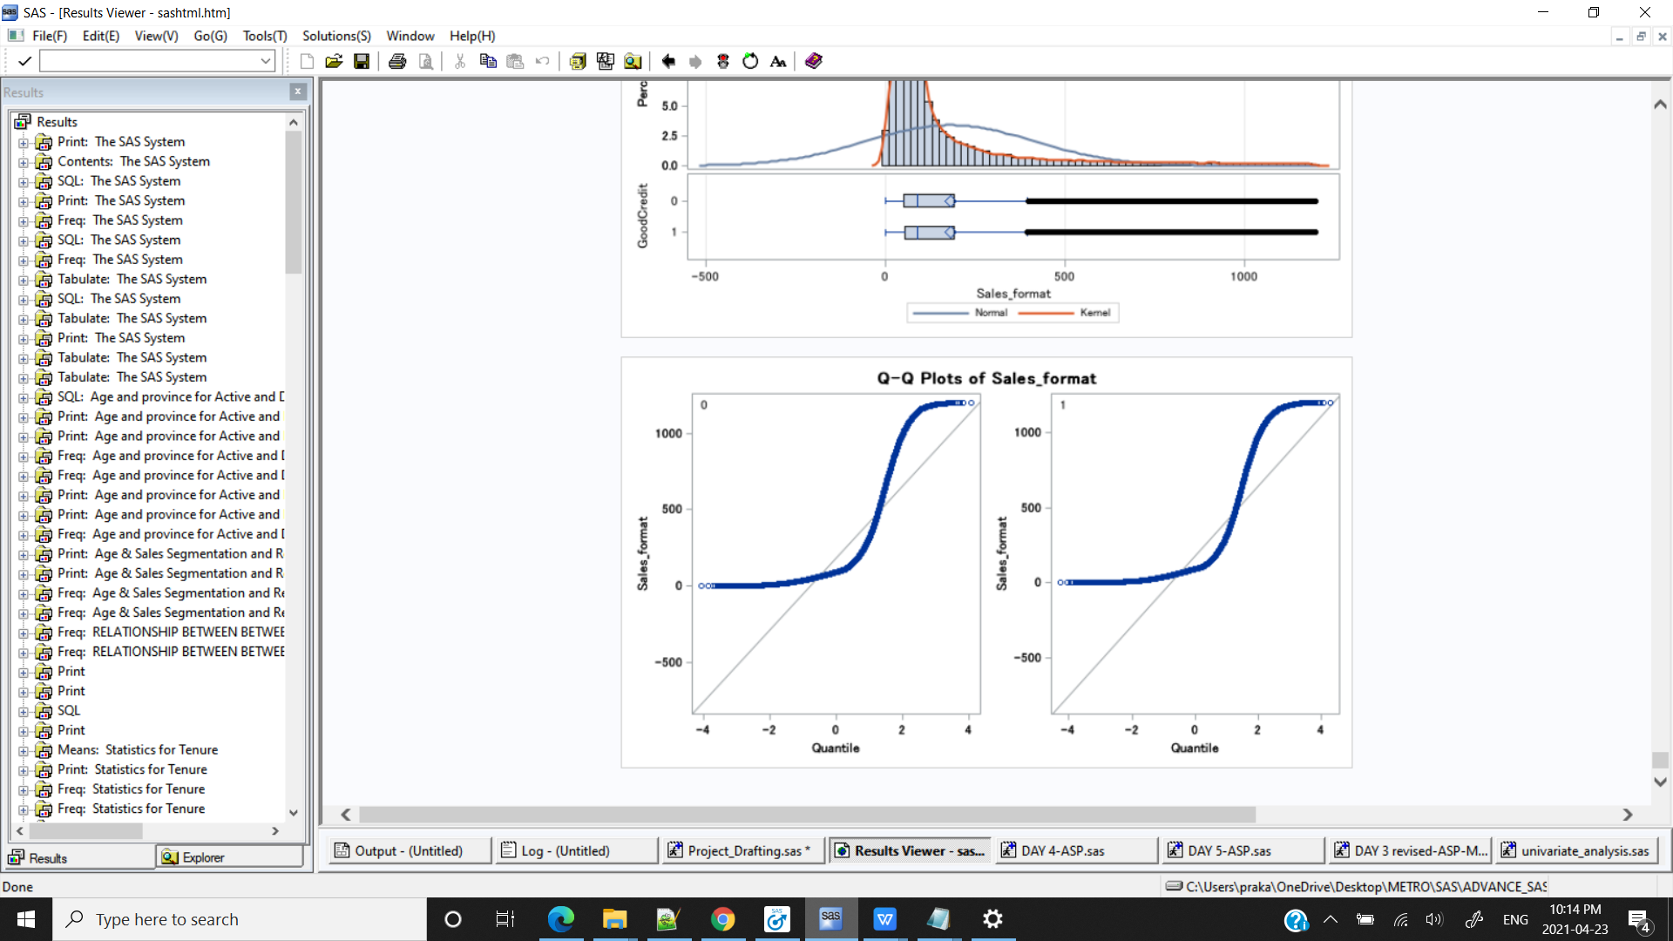

**/*CONCLUSION: Here the p-value is 0.2878 which is greater than significance level hence we fail to reject the Null Hypothesis.There is no association between Sales and Goodcredit*/**

/*SAS SYNTAX*/

/*SAles and CUSTOMER_AGE_SEGMENTS*/

/*

Null Hypothesis : There is no association between Sales and customer age segments

Alternative Hypothesis: There is association between Sales and customer age segments

*/

/*Appling the age format on age column*/

**data** kp.test7;

set kp.test2;

format Age agefmt.;

**run**;

**proc** **print** data=kp.test7(obs=**10**);**run**;

**PROC** **ANOVA** DATA = kp.test7;

CLASS Age;

MODEL Sales_format = Age;

MEANS Age/Scheffe;/*we can consider that at least two group means are statistically signicant from each other if p-value is less than 0.05. So far, the ANOVA only tells you all group means are not statistically significant equal. It does not tell you where the difference lies. For further multiple comparison, we still need Scheffe’s or Tukey test.*/

TITLE "Sales for different customer age groups";

**RUN**;

**QUIT**;

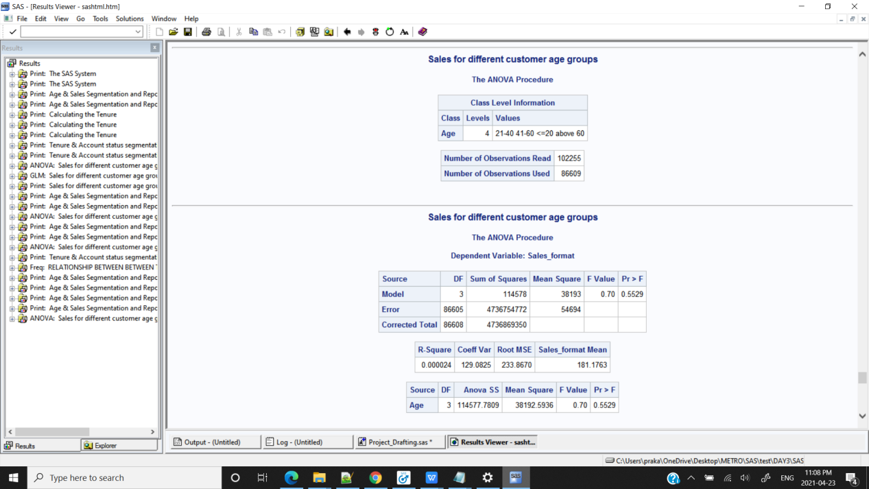

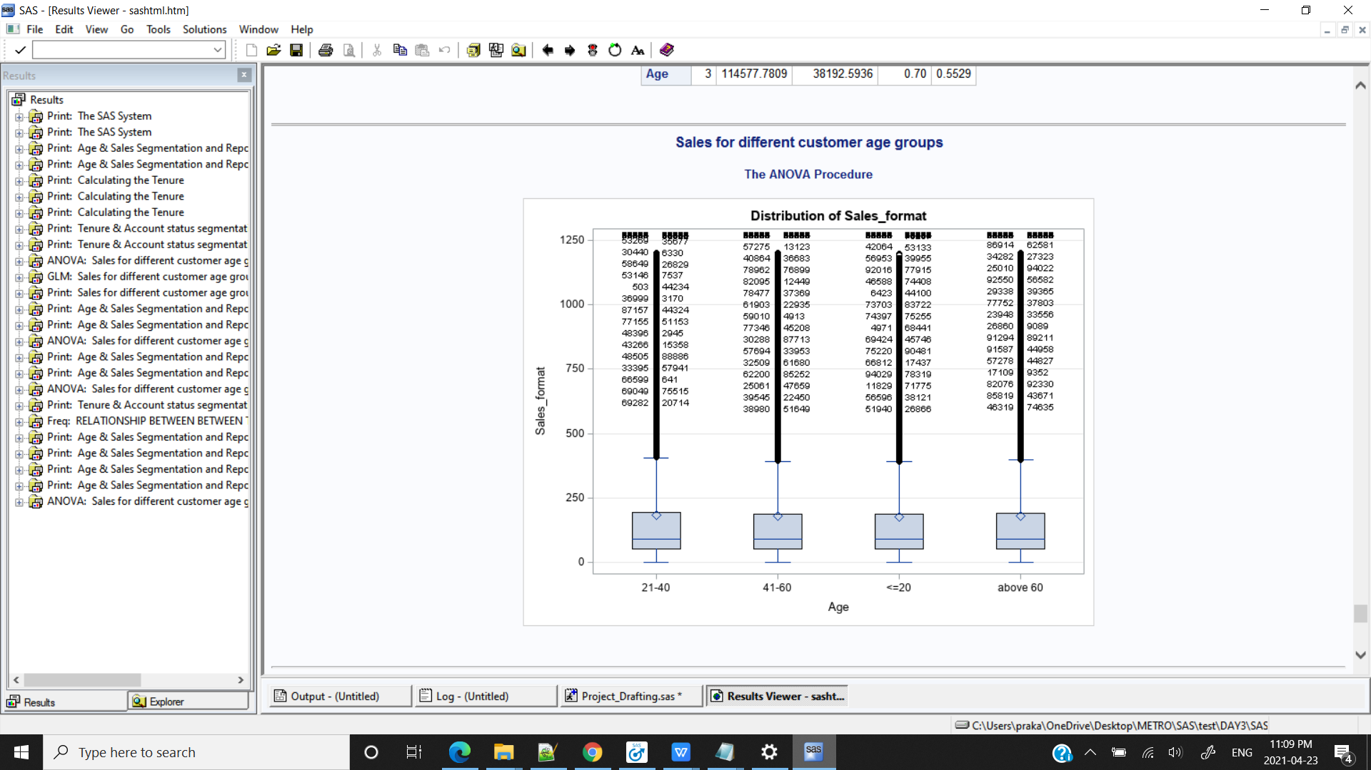

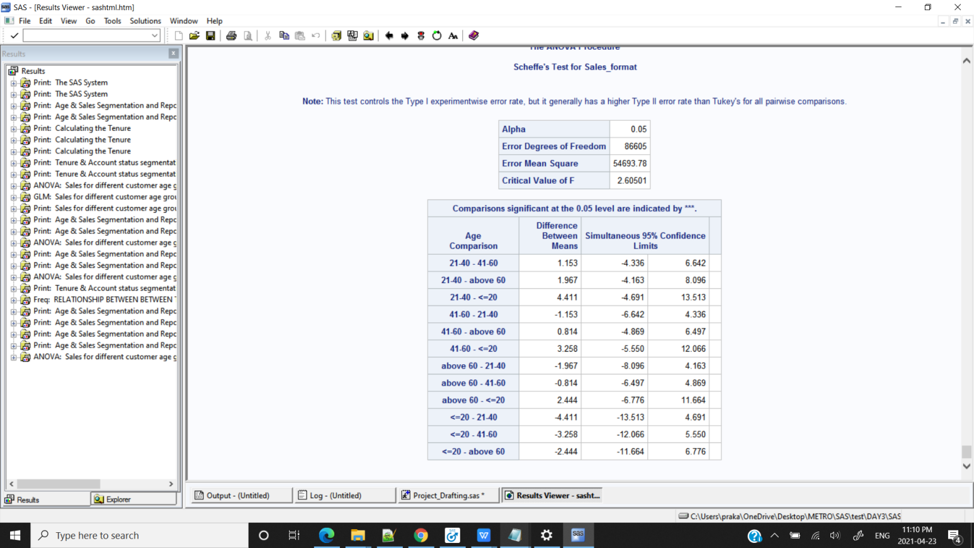

**/*CONCLUSION: Here the p-value is 0.7179 which is greater than significance level hence we fail to reject the Null Hypothesis.There is no association between Sales and Customer age segments*/**

**proc** **glm** data=kp.test7;

class Age;

model Sales_format = Age;

means Sales_format / hovtest=levene(type=abs) welch;

**run**;

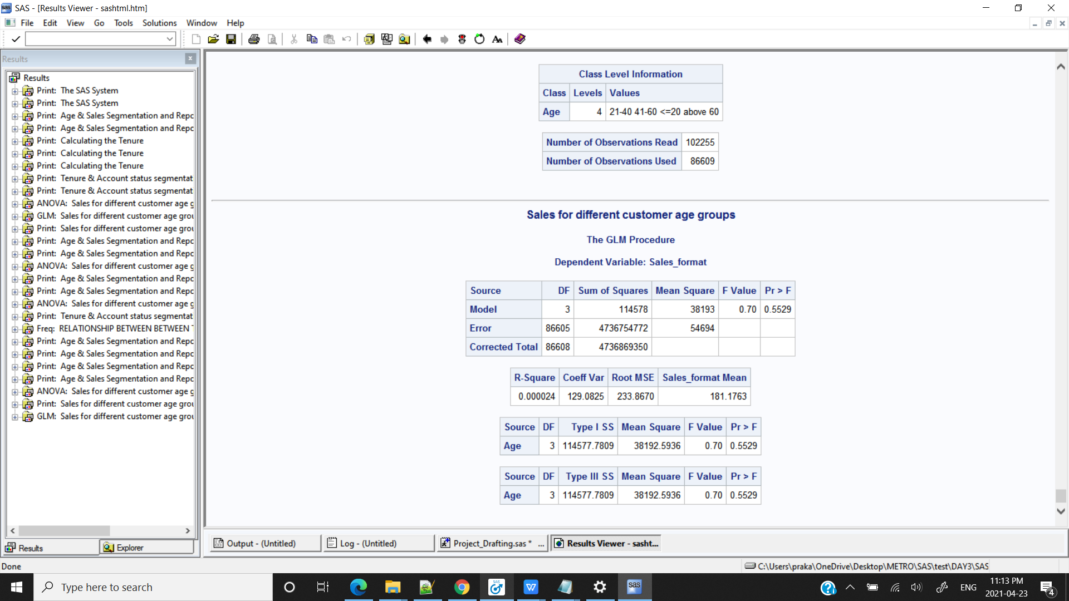

**DATA VISUALIZATION**

%include "C:\Users\praka\OneDrive\Desktop\METRO\SAS\ADVANCE_SAS\PROJECT\univariate_analysis.sas";

%***UNI_ANALYSIS_CAT_FORMAT***(kp.test2,Account_Status)

%***UNI_ANALYSIS_CAT_FORMAT***(kp.test0,Age,Agefmt.)

%***UNI_ANALYSIS_CAT_FORMAT***(kp.test0,Sales_format,Salesfmt.)

%***UNI_ANALYSIS_CAT_FORMAT***(kp.test5,TENURE,tenurefmt.)

%***UNI_ANALYSIS_NUM***(kp.test2,Sales_format)

%***UNI_ANALYSIS_NUM***(kp.test,Tenure)

%***FREQ_AND_Visual_cat***(kp.test4,Account_Status)

%***BI_ANALYSIS_NUMs_CAT*** (DSN =kp.test6 ,CLASS=Account_Status , VAR=TENURE );

**CONCLUSION & RECOMMENDATION :**

1. It is observed that customers with age of 41 to 52 are occuring frequently in both the cases.

RECOMMENDATION:Special offers or promotions to grab customers from other age groups

1. There are high percentage of customers discontinuing the service within 6 months to one year,if they are continuing beyond one year chances of churning out is very low.

RECOMMENDATION :Proactive Customer Service

1. Highest number of Sales is from Very low Sales group i.e. the amount of Sales is very low below(>100)

RECOMMENDATION: To design the Rateplan which could give more sales like 1

1. CONCLUSION : Highest percent of churn rate observed in the month of December & also in month of October November & January

RECOMMENDATION : Retaining the customers before last quarter of the year by giving

special offers